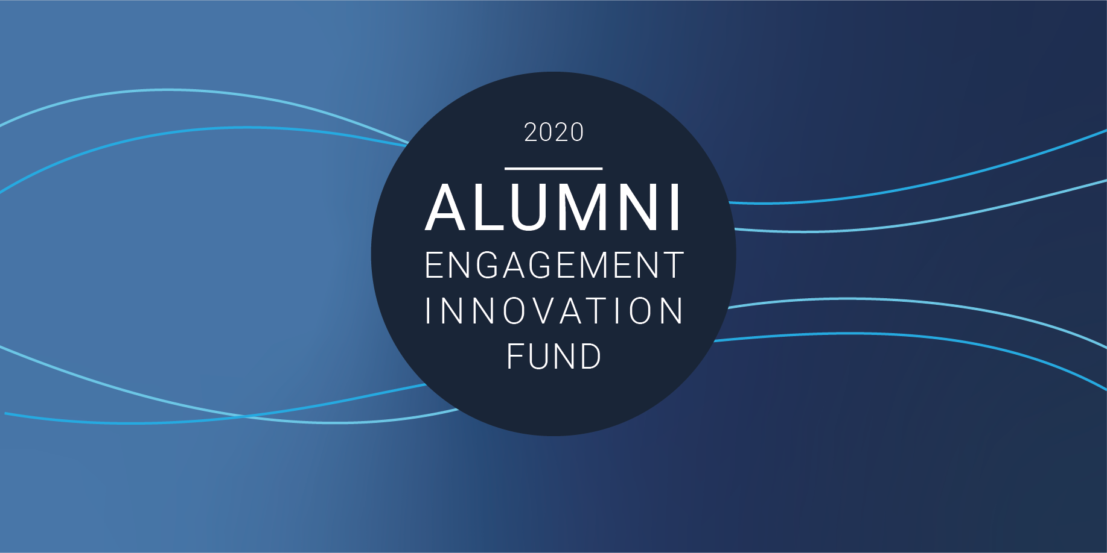
APPLICATION FORM

AEIF 2020 supports teams of at least two alumni of U.S. government-sponsored international exchange programs with funding from US $5,000 up to US $25,000 to support public service projects. The global AEIF 2020 competition will provide resources for alumni projects around the world to advance women’s and girls’ safety and their meaningful participation in peace and security processes. Alumni interested in submitting applications to AEIF 2020 should contact the U.S. embassy or consulate in your country (https://www.usembassy.gov/).

About Your Project
Project Title:
 | Projects must support women, peace, and security in areas such as:
Project Theme: Select which theme(s) your proposal addresses | ☐ Strengthen the role of women in peace, security, and governance  ☐ Engage women as partners in preventing terrorism and countering radicalization and recruitment  ☐ Promote protection of women and girls from violence, abuse, and exploitation  ☐ Support women’s political, economic, and civic participation
Primary Location of Project:
If the project is taking place in multiple cities, states, or provinces within the same country, please enter all locations separated by a comma.
Country:
City or Town:
State or Province:
Will you project take place in additional countries?
If YES, please specify up to two additional countries.
Proposal Summary:
Please provide a 3-4 sentence summary of your project.

Alumni Team Information
There must be at least two exchange alumni team members for a project to be considered for funding. Along with the name and contact information, describe the role each team member will have in the project and their experience, qualifications, and ability to carry out that role. Indicate what proportion of their time will be used in support of the project. (250 word limit for each).
Team Leader 1: | First Name:
 | Last Name:
 | Exchange Program:
 | E-Mail:
 | Country From:
 | Role of Team Leader and Qualifications:
Team Leader 2: | First Name:
 | Last Name:
 | Exchange Program:
 | E-Mail:
 | Country From:
 | Role of Team Leader and Qualifications:
Team Member 1: | First Name:
(As needed) | Last Name:
 | Exchange Program:
 | E-Mail:
 | Country From:
 | Role of Team Member 1 and Qualifications:

Team Member 2: | First Name:
(As needed) | Last Name:
 | Exchange Program:
 | E-Mail:
 | Country From:
 | Role of Team Member 2 and Qualifications:
Team Member 3: | First Name:
(As needed) | Last Name:
 | Exchange Program:
 | E-Mail:
 | Country From:
 | Role of Team Member 3 and Qualifications:

Detailed Project Description
Problem Statement (150 word limit - 3 to 4 sentences):
Describe the specific need or challenge regarding (or relating to) women, peace, and security that your team will address with this project:

Program Goals and Objectives (500 word limit):
How will your will address the need or challenge? How will the project impact the community and what changes (in people, institutions, attitudes, or practices) will you see?

Local Program Partners (500 word limit):
List partners who will support your project. Please note if you have an existing relationship with your partner organization(s) and describe their role in the project. If you do not have an existing relationship, how do you anticipate establishing a partnership with the organization(s)?

Program Methods and Design: Proposed Program Schedule, Timeline, and Beneficiaries
Program Methods and Design (750 word limit):
In this section, explain how the program is expected to work to solve the stated problem and achieve the goal. Include a proposed timeline for the program activities. Include the dates, times, and locations of planned activities and events. Describe the groups or communities your project targets (beneficiaries). How many direct and indirect beneficiaries do you estimate your project will benefit?

Program Monitoring and Evaluation Plan
Proposed Project Schedule and Timeline (750 word limit):
The proposed timeline for the project activities. Include the dates, times, and locations of planned activities and events
Program Monitoring and Evaluation Plan
Evaluation (350 word limit):
Explain how you will know your project is a success and impacts the targeted beneficiaries. In this section, explain how you will monitor the activities to ensure they are happening in a timely manner throughout the time-frame of the grant. How will the program be evaluated to make sure it is meeting the goals of the project? Explain any tools or methods you will utilize to measure results (such as surveys, interviews, focus groups, meetings, analytics, metrics, etc.)

Sustainability (350 word limit):
How do you plan for continuing the program beyond the grant period, or the availability of other resources, if applicable.

Communication Plan (350 word limit):
How will you promote your project? Include social media, websites, print news, or other forms of media you intend to use to share information about your project to beneficiaries and the public.

Please list any websites or social media platforms or accounts that you may have for your project in the fields below: (Optional)
Website:
Facebook:
Twitter:
Instagram:
YouTube:
Other:

Funding Information and Budget
*The budget must be submitted as a separate Excel file, using the template provided by the U.S. embassy or consulate sponsoring the grant competition.

Alumni can request between $5,000 and $25,000. Projects that request lower than $5,000, or higher than $25,000 will be disqualified.
Total Requested:
Budget Justification Narrative
In this section, refer to your budget form and provide a narrative explanation of how the costs listed are necessary for the activities associated with your project. Please provide details as to how you arrived at the calculations for both the costs you are requesting from AEIF, and also for cost share/in-kind support. If your budget has NO costs associated with a category, please right “N/A” in the field.
Venue:
Promotional Items:
Meals and Beverages:
Speaker Fees:
Lodging and Per Diem:
Travel:
Supplies, Materials, and Equipment:
Other:

