U.S. DEPARTMENT OF STATE
U.S. EMBASSY Yaoundé, Cameroon
Notice of Funding Opportunity

Funding Opportunity Title: PEPFAR Small Grants Program POL/ECON, U.S. Embassy Yaounde
Funding Opportunity Number: AFYDE-PSGCLM-GR-POLECON-2022
Deadline for Applications: October 30, 2022
Assistance Listing Number: 19.029
Total Amount Available: $100,000

A. PROGRAM DESCRIPTION
The U.S. Embassy in Yaoundé-Cameroon, Political and Economic Section, of the U.S. Department of State announces an open competition for organizations to submit applications under the FY 2023 PEPFAR Small Grants, to carry out Community Led Monitoring Activities-Key Populations (KP) oriented program. Please follow all instructions below.

Priority Region:

- Monitoring of both Community and Clinical Sites at the following locations:
  - Bamenda, Bafoussam, Bertoua, Douala, Yaounde, Kribi, N'Gaoundere;
- Monitoring of only clinical sites at the following locations:
  - Buea, Limbe, Dschang & Foumbot
In these cities, implementers will work in, but not limited to:
- Facilities
- Drop-in centers
- Hot spots

A.1. Background and Context:

Community-led monitoring (CLM) is a technique initiated and implemented by local community-based organizations and other civil society groups, networks of key populations (KP), people living with HIV (PLHIV), and other affected groups, or other community entities that gather quantitative and qualitative data on the quality of HIV services.

In Cameroon, the monitoring of the implementation of HIV services started with an observatory called Treatment Access Watch (TAW) in 2009 and implemented by the civil society Organization-Positive Generation (PG), in some health districts of the country. Its main focus was and has been to: (1) Increase accountability by national and donor HIV programs to communities and beneficiaries; (2) Reduce instances of rights violations including denial of patient rights, stigma, and discrimination; (3) Increase engagement of communities in programme quality improvement; (4) Act as an immediate watch dog for stockouts in specific service delivery locations and avoid future stouts of essential health commodities; (5) Monitor the availability of health services and products and the extent to which members of the community have access to them etc.

In 2020, the benchmark policy shift in the national HIV response, with the elimination of HIV formal and informal user fees, it became evident that the country needed to add-up and bring the CLM mechanism to scale to monitor policy adherence and implementation in-country. The U.S Government through PEPFAR, took the lead in mainstreaming the implementation of this CLM on the general population to (1) Monitor the effect of national policies on local beneficiaries and whether policy recommendations or edicts are being respected and (2) to quickly identify and resolve challenges and barriers to the access and quality of HIV care.

In 2021, other donors, including the Global Fund, UNAIDS, GIZ, Expertise France, local NGOs and other local and international funders invested resources in Community Led Advocacy and Research (CLAR), which aims at strengthening the utilization of evidence-based findings to advocate for the improving of access to HIV care. This CLM will be led by representatives of the civil society at the Country Coordination Mechanism of the Global Fund and implemented by CSOs in Cameroon under the leadership of the Civil Society Coordination Platform of Cameroon.
That same year, in 2021, PEPFAR Cameroon, through the Ambassador’s Small Grants initiatives launched a CLM initiative with the collective objective of developing a shared understanding of the enablers and barriers to access HIV services (HIV prevention, testing, linkage, treatment retention, VL) on PEPFAR supported sites in a manner that is productive, collaborative, respectful, and solutions oriented. The first phase kicked-off during COP20 FY21 implementation and the second phase is still on course.

Despite the existence of these different CLM initiatives, none are specific to the needs of Key Populations and AGYW. Whereas in a country like Cameroon where Key Populations are most vulnerable due to punitive laws and a criminalized context; with a growing rate of new infections amongst adolescences and young people, an evidence-based monitoring mechanism of access to quality HIV services by these population sub-groups is necessary.

It is in this regard that PEPFAR is also going more specific in its CLM initiatives to target specific vulnerable population groups, including Key Populations and AGYW, in its 2022 Country Operational Plan. While PEPFAR/USAID will add the AGYW CLM initiative to its already existing general population CLM, the PEPFAR Coordination Office, through the Ambassador’s Small Grants will implement the KP component.

A.2 Rationale

The legal environment is not KP accommodating in Cameroon. Members of the LGBTI community are often victims of violence and human rights violations: according to the 2021 report of Unity Platform there were 2031 cases of violence targeting LGBTI in 2020 and 4116 cases in 2021. Despite advancements in HIV care and prevention, HIV stigma and discrimination continue to undermine the quality of people living with HIV (PLHIV). In Cameroon, the report mentioned above states that " Stigma and discrimination experienced in health care settings (facility and community) is a limiting factor of KP’s access to testing, treatment and viral load suppression. HIV will remain unattainable by 2030 unless structural barriers that limit access to health care for key populations are removed.

In terms of accountability in HIV, decision-makers are rarely also users of the KP-related HIV health services over which they exercise control, and, in many cases, they are not directly accountable to those who are. Addressing continuing challenges in the quality of and access to services is inextricably linked to addressing this accountability deficit in the HIV response particularly for KP.

In front of these challenges, and in view of monitoring the systems PEPFAR Cameroon has put in place to break these structural limitations and improve KP access to HIV care and other social services, the fifth (5) minimum program requirement of the COP 22 Planning Level Letter requires that countries’ CLM activities must include provision for distinct participation and leadership for KP. The focus of this KP-led CLM activity is on getting input from KP recipients of HIV services in a routine and systematic manner that will translate into action and change.

Empowering KP communities and patients, through this CLM, to monitor the services of which they are prime beneficiaries is as critical as controlling the HIV epidemic itself. Collaborating with KP communities in a manner that will identify their persistent barriers and enablers to accessing and utilizing HIV, social and legal services is pivotal to PEPFAR’s people-centered focus.

A.3 Program Objectives:

- General Objectives
To improve KP specific HIV service delivery and outcomes by identifying and understanding data-driven solutions to overcome barriers and ensure KPs receive optimal people-centered HIV services in a manner that is productive, collaborative, respectful, and solutions-oriented.

- Specific Objectives
- To spot check the implementation of comprehensive and quality KP HIV services.
- To monitor the availability and accessibility of KP specific services and health commodities.
- To improve accountability and responsiveness in service delivery.
- To report on KP experiences of violence, stigma and discrimination.
- To monitor the implementation of promised changes.

A.5 Participants and Audiences:

The intended group of audience is KP-led networks of CBOs covering the four KP sub-group populations, including, Men who have Sex with Men (MSM), Female Sex Workers (FSW), People Who Inject Drugs (PWID), and Transgender (TG).

A.4 Design: Key interventions through six stages

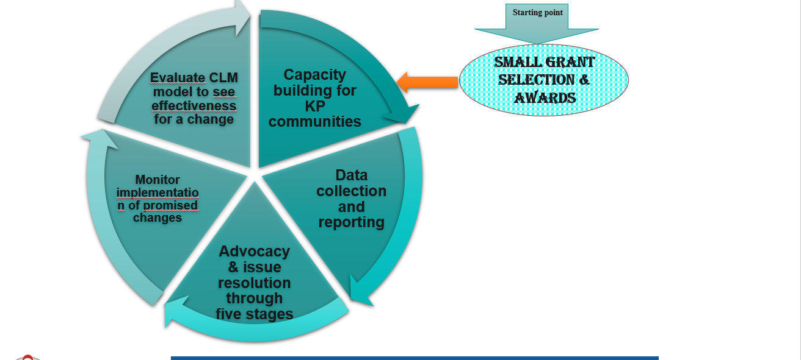

a) Capacity building for KP communities
Communities will be sensitized and trained on:
- Their rights to care, access to quality differentiated HIV services for KP at both facility and community levels;
- What services to expect from the health facilities and the communities, so they clearly understand what is working and not working as planned;
- CLM objectives, standardized tools and dashboards as well as monitoring and reporting skills;
- Population size estimates to use and the cities to cover;
- Advocacy skills so that they can actively improve service delivery, quality, and availability in their locations.
b) Data Collection & Reporting
i) Data Collection
Data will be collected only on services supported by PEPFAR. The data will cover availability, quality of service, costed/free services etc… These services are illustrated below:

- Indicators will be built off these services for quantitative analysis to be carried-out;
- CLM data will be collected using standardized tools and synthesized through a variety of methods that reveal insights from communities about problems and solutions to health and HIV services delivery at the facility, community, sub-national and national levels;
- The data will be collected systematically and routinely, with follow up and continuous improvement;
- The data will be tailored to the needs identified by KP community members, with communities directly determining the scope allow for community and host country government development of the specific metrics, measures or tools to be used for community-led monitoring. In addition, the designed tools will capture the service packages of all KP sub groups including MSM, FSW, PWIDs and TG.
- The data will be triangulated with, but not duplicative of, other PEPFAR data streams. CLM data should reflect an ‘added value’ and not duplicate collection of routine data already available to PEPFAR through Monitoring Evaluation and Reporting (MER) indicators. ‘Added value’ monitoring data includes: information from beneficiaries about their experience with the health facility and communities, information about barriers and enablers to access and retention in services;
- There is no expectation that data from community-led monitoring activities will be reported to S/GAC through current PEPFAR reporting mechanisms such as the POARTS.
ii) Reporting Findings
CLM findings will be presented and analyzed in collaboration with local authorities, community representatives and hospital managements to promote dialogue and help all parties participate in the identification of solutions and subsequently the implementation and monitoring of the solutions. This effort will generate problem-solving information that is focused on the goal of improving service quality, continuity, and retention.

Reporting findings will be done at different levels as shown on the figure below:
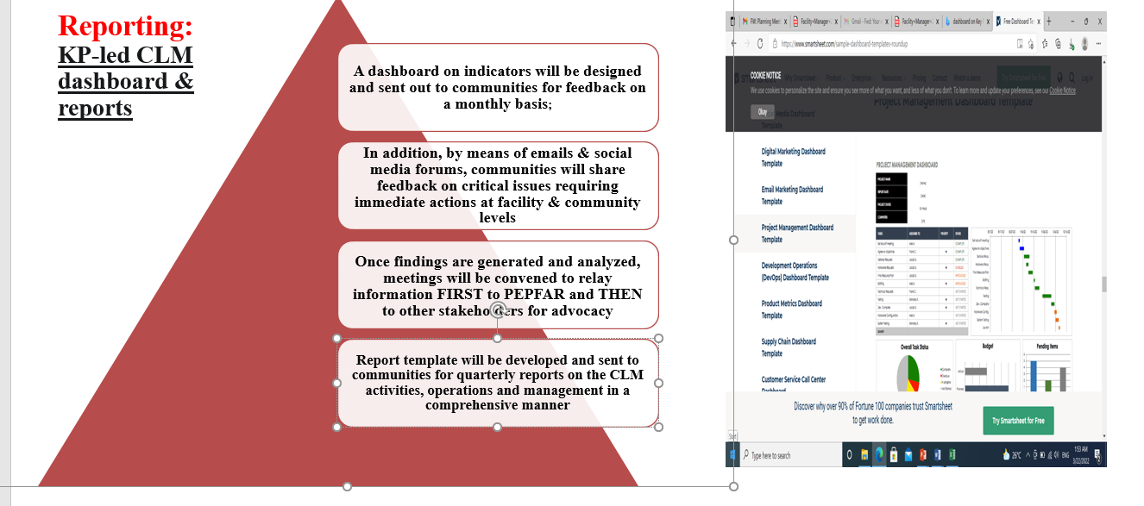

c) Problem resolution and Advocacy through five stages
This will start at the IP levels. There will be a feedback mechanism to PEPFAR IPs and resolution of issues should start at that level. After this level, feedback will be shared with both the PEPFAR interagency and S/GAC. This is indicated on the figure below.
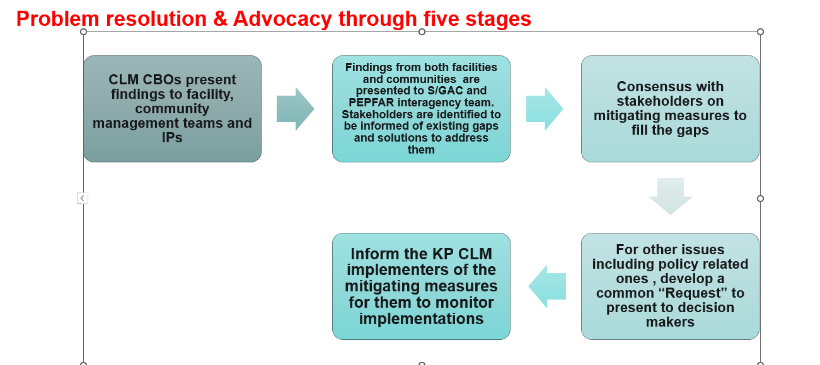
d) Monitor implementation of promised changes
- Actions-oriented with an associated follow-up process with the health facilities and communities that is overseen by IPs and U.S. government staff, committed to corrective public health action, and involves community advocacy;
- KP CLM implementers will monitor their implementation at both the facilities and communities;
- The follow-up will be regularly done and feedback will return to PEPFAR through the dashboard monthly;
- Once issues are resolved, communications acknowledging and appreciating the resolution will be sent to the relevant authorities highlighting that previously identified challenges/gaps have been resolved and that service delivery is efficient.

A.5 Methodology to determine sample size
For the purpose of this monitoring exercise, the Raosoft method was used to determine the population size. It is worth noting that, this method can either be used manually or electronically. The formula below is used for determining the population size manually:
Sample size = (Z-score)² x StdDev x (1-StdDev)
(confidence interval)²
Electronically, the Raosoft software can also be used through the following link: http://www.raosoft.com/samplesize.html
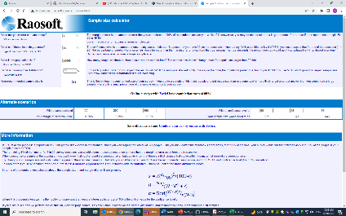
For time efficiency, the software was used to determine the population sizes of the targeted population of this monitoring exercise.

PWID
Number | Region | Total pop size | Sample size
1 | Adamawa | 36 | 32
2 | Centre | 245 | 129
3 | East | 38 | 34
4 | Littoral | 392 | 161
5 | North West | 72 | 58
6 | West | 16 | 16
7 | South | 27 | 25
8 | South West | 13 | 13

MSM
Number | Region | Total pop size | Sample size
1 | Adamawa | 1077 | 217
2 | Centre | 3902 | 254
3 | East | 789 | 202
4 | Littoral | 2818 | 247
5 | North | 2 | 2
6 | North West | 537 | 181
7 | West | 463 | 171
8 | South | 719 | 197
9 | South West | 10 | 10
FSW
Number | Region | Total pop size | Sample size
1 | Adamawa | 2396 | 244
2 | Centre | 4996 | 257
3 | East | 2197 | 241
4 | Littoral | 5803 | 259
5 | North | 5 | 5
7 | North West | 2942 | 248
8 | West | 838 | 205
9 | South | 1145 | 219
10 | South West | 139 | 93

PEOPLE IN PRISONS
Number | Region | Total pop size | Sample size
1 | Adamawa | 470 | 172
2 | Centre | 213 | 120
3 | East | 37 | 33
4 | Littoral | 1044 | 216
5 | North | 2 | 2
6 | West | 729 | 198
7 | South | 39 | 35
8 | South West | 11 | 11

TG
Number | Region | Total pop size | Sample size
1 | Centre | 44 | 38
2 | Littoral | 248 | 130
3 | North West | 41 | 36
4 | South | 1 | 1

B. FEDERAL AWARD INFORMATION
Length of performance period: 11 months
Number of awards anticipated: 01 awards
Award amounts: awards may range from a minimum of $100,000 to a maximum of $100,000
Total available funding: $100,000
Type of Funding: FY22/23 Economic Support Funds under the Foreign Assistance Act
Anticipated program start date: November 15

This notice is subject to availability of funding.

Funding Instrument Type: Cooperative agreement

The U.S. Embassy in Cameroon anticipates awarding cooperative agreements as a result of this NOFO. Cooperative agreements are different from grants in that embassy staff are more actively involved in the grant implementation.
Examples of substantial involvement for this project may include, but are not limited to, the following:
- Approving selected regions and target per organization
- Reviewing and approving the recipient’s implementation work plan to achieve the
- expected results
- Contribute and approving training modules contents
- Participating in the selection process of key stakeholders to be trained
- Providing guidance related to the recipient’s implementation plan for trainings and
- meetings with government officials and other key stakeholders.
Program Performance Period: Proposed programs should be completed in 11 months (November 2022 – September 2023) or less.

C. ELIGILIBITY INFORMATION

- Eligible Applicants

The following organizations are eligible to apply: This CLM will be conducted objectively by KP-led independent Cameroonian locally registered organizations and more precisely by through KP-led networks consisting of CBOs which cover KP sub-groups including: MSM, FSW, PWID, TG.

PEPFAR Implementing partners who currently work on service delivery at clinical and community sites cannot be funded to do this work, even if they will sub-grant to a local civil society organization.

- Cost Sharing or Matching

Providing cost sharing, matching, or cost participation is not an eligibility requirement for this NOFO.

- Other Eligibility Requirements

In order to be eligible to receive an award, all organizations must have a Unique Entity Identifier (UEI) number issued via www.SAM.gov as well as a valid registration on www.SAM.gov. Please see Section D.3 for more information. Individuals are not required to have a UEI or be registered in SAM.gov.

Applicants are only allowed to submit one proposal per organization/Network. If more than one proposal is submitted from an organization/Network, all proposals from that institution will be considered ineligible for funding.

Organizations must have a commitment to equal opportunity employment practices and to non-discrimination practices with regard to beneficiaries, without regard to race, religion, ethnicity, gender, sexual orientation, or political affiliation

D. APPLICATION AND SUBMISSION INFORMATION

D.1 Address to Request Application Package

Application forms required below are available at: embassy website and grants.gov.

D.2 Content and Form of Application Submission

Please follow all instructions below carefully. Proposals that do not meet the requirements of this announcement or fail to comply with the stated requirements will be ineligible.

- Content of Application
Please ensure:
- The proposal clearly addresses the goals and objectives of this funding opportunity
- All documents are in English
- All budgets are in U.S. dollars
- All pages are numbered
- All documents are formatted to 8 ½ x 11 paper, and
- All Microsoft Word documents are single-spaced, 12 point Times New Roman font, with a minimum of 1-inch margins.

The following documents are required:

D.3 Mandatory application forms
- SF-424 (Application for Federal Assistance – organizations)
- SF-424A (Budget Information for Non-Construction programs)
- SF-424B (Assurances for Non-Construction programs) (note: the SF-424B is only required for individuals and for organizations not registered in SAM.gov)

D.4 Summary Page: Cover sheet stating the applicant name and organization, proposal date, program title, program period proposed start and end date, and brief purpose of the program.

D.5 Proposal (20 pages maximum): The proposal should contain sufficient information that anyone not familiar with it would understand exactly what the applicant wants to do. You may use your own proposal format, but it must include all the items below.
- Proposal Summary: Short narrative that outlines the proposed program, including program objectives and anticipated impact.
- Introduction to the Organization or Individual applying: A description of past and present operations, showing ability to carry out the program, including information on all previous grants from the U.S. Embassy and/or U.S. government agencies.
- Problem Statement: Clear, concise and well-supported statement of the problem to be addressed and why the proposed program is needed
- Program Goals and Objectives: The “goals” describe what the program is intended to achieve. The “objectives” refer to the intermediate accomplishments on the way to the goals. These should be achievable and measurable.
- Program Activities: Describe the program activities and how they will help achieve the objectives.
- Program Methods and Design: A description of how the program is expected to work to solve the stated problem and achieve the goal. Include a logic model as appropriate.
- Proposed Program Schedule and Timeline: The proposed timeline for the program activities. Include the dates, times, and locations of planned activities and events.
- Key Personnel: Names, titles, roles and experience/qualifications of key personnel involved in the program. What proportion of their time will be used in support of this program?
- Program Partners: List the names and type of involvement of key partner organizations and sub-awardees.
- Program Monitoring and Evaluation Plan: This is an important part of successful grants. Throughout the time-frame of the grant, how will the activities be monitored to ensure they are happening in a timely manner, and how will the program be evaluated to make sure it is meeting the goals of the grant?
- Future Funding or Sustainability Applicant’s plan for continuing the program beyond the grant period, or the availability of other resources, if applicable.

D.6. Budget Justification Narrative: After filling out the SF-424A Budget (above), use a separate sheet of paper to describe each of the budget expenses in detail. See section H. Other Information: Guidelines for Budget Submissions below for further information.

D.7. Attachments :
- 1-page CV or resume of key personnel who are proposed for the program
- Letters of support from program partners describing the roles and responsibilities of each partner (CBOs enrolled in the network)
- If your organization has a Negotiated Indirect Cost Rate Agreement (NICRA) and includes NICRA charges in the budget, your latest NICRA should be included as a PDF file.
- Official permission letters, if required for program activities

D.8 Unique Entity Identifier and System for Award Management (SAM.gov) (NOTE: This section is required and not optional, except for NOFOs targeting applications from individuals instead of organizations)

D.9 Required Registrations:

All organizations applying for grants (except individuals) must obtain these registrations. All are free of charge:
- www.SAM.gov registration which will generate a UEI
- NCAGE/CAGE code

Any applicant with an exclusion in the System for Award Management (SAM) is not eligible to apply for an assistance award in accordance with the OMB guidelines at 2 CFR 180 that implement Executive Orders 12549 (3 CFR, 1986 Comp., p. 189) and 12689 (3 CFR, 1989 Comp., p. 235), “Debarment and Suspension.”

The Unique Entity Identifier (UEI) is one of the data elements mandated by Public Law 109-282, the Federal Funding Accountability and Transparency Act (FFATA), for all Federal awards. SAM.gov is the Federal government's primary database for complying with FFATA reporting requirements. OMB designated SAM.gov as the central repository to facilitate applicant and recipient use of a single public website that consolidates data on all federal financial assistance. Under the law, it is mandatory to register in SAM.gov.

Starting April 2022, the UEI will be assigned when an organization registers or renews it’s registration in SAM.gov at www.SAM.gov. To access SAM.gov an organization is required to have a Login.gov account. Organization can create an account at https://login.gov/. As a reminder, organizations need to renew its sam.gov registration annually.

US-based organizations: A CAGE code will be automatically assigned when the U.S. organizations registers in www.sam.gov. CAGE must be renewed every 5 years. Site for CAGE: https://cage.dla.mil/Home/UsageAgree. Grantees may be asked for more information to finalized and must comply.

Foreign-based organizations: Must apply for a NCAGE code before registering in SAM.gov. Go to: https://eportal.nspa.nato.int/AC135Public/CageTool/home to apply for a NCAGE code. NCAGE codes must be renewed every 5 years.

It is in the organization’s best interest to check if their CAGE/or NCAGE codes are active. Organizations are required to register/or renew their CAGE or NCAGE codes prior to registering or renewing www.sam.gov . Both registration and renewals for both CAGE and NCAGE can take up to 10 days. Organization’s legal address in NCAGE/CAGE must mirror www. sam.gov.

www.sam.gov requires all entities to renew their registration once a year in order to maintain an active registration status in SAM.gov. It is the responsibility of the applicant to ensure it has an active registration in SAM.gov.

If an organization plans to issue a sub-contract or sub-award, those sub-awardees must also have a unique entity identifier (UEI number). Those entities can register for a UEI only at SAM.gov.

If an organization does not have an active registration in SAM.gov prior to submitting an application, the application will be deemed ineligible. All organizations applying for grants (except individuals) must obtain these registrations, the latter are free of charge.

Note: As of April 2022, a DUNS number is no longer required.

D.10 Submission Dates and Times

Applications are due no later than 11:59 PM Cameroon time on October 30, 2022.

D.11 Funding Restrictions

The following activities and costs are not covered under this announcement:
- Construction is not an allowable activity under this award.
- Activities that appear partisan or that support individual or party electoral campaigns.
- Direct support or the appearance of direct support for any religious organization, to include repair or building of structures used for religious purposes.
- Military assistance of any kind, including weapons buy-back or rewards programs.
- Purchase of firearms, ammunition, or removal of unexploded ordnances.
- Para-police (i.e., militias, neighborhood watch, security guards) and prison-related projects. This restriction includes no funding of any secondary need in a law-enforcement organization.
- Payments for any partner government, military, or civilian government employee salary or pension.
- Duplication of services immediately available through municipal, provincial, or national government.
- Funds for market research, advertising (unless public service related to grant program), or other promotional expenses.
- Expenses made prior to the approval of a proposal or unreasonable expenditures will not be reimbursed.
- Charitable or development activities;
- Fund-raising campaigns;
- Lobbying for specific legislation or projects;
- Scientific research;
- Projects intended primarily for the growth or institutional development of the organization;
- Projects seeking funds for personal use;
- Projects that require a participation fee.

D.12 Other Submission Requirements

All application materials must be submitted by email to grantsyaounde@state.gov .
Faxed or couriered document will not be accepted.

E. APPLICATION REVIEW INFORMATION

E.1 Criteria

Each application will be evaluated and rated on the basis of the evaluation criteria outlined below.

Quality and Feasibility of the Program Idea – 20 points: The program idea is well developed, with detail about how program activities will be carried out. The proposal includes a reasonable implementation timeline.
Organizational Capacity and Record on Previous Grants – 20 points: The organization has expertise in its stated field and has the internal controls in place to manage federal funds. This includes a financial management system and a bank account.

Program Planning/Ability to Achieve Objectives – 15 points: Goals and objectives are clearly stated and program approach is likely to provide maximum impact in achieving the proposed results.
Budget – 10 points: The budget justification is detailed. Costs are reasonable in relation to the proposed activities and anticipated results. The budget is realistic, accounting for all necessary expenses to achieve proposed activities.
Monitoring and evaluation plan – 15 points: Applicant demonstrates it is able to measure program success against key indicators and provides milestones to indicate progress toward goals outlined in the proposal. The program includes output and outcome indicators, and shows how and when those will be measured.
Sustainability – 10 points: Program activities will continue to have positive impact after the end of the program.

Support of Equity and Underserved Communities – 10 points: Proposals should clearly demonstrate how the program will support and advance equity and engage underserved communities in program administration, design, and implementation.

E.2 Review and Selection Process

A review committee will evaluate all eligible applications.

E.3 Federal Awardee Performance & Integrity Information System (FAPIIS)

For any Federal award under a notice of funding opportunity, if the Federal awarding agency anticipates that the total Federal share will be greater than the simplified acquisition threshold on any Federal award under a notice of funding opportunity may include, over the period of performance (see §200.88 Simplified Acquisition Threshold), this section must also inform applicants:

i. That the Federal awarding agency, prior to making a Federal award with a total amount of Federal share greater than the simplified acquisition threshold, is required to review and consider any information about the applicant that is in the designated integrity and performance system accessible through SAM (currently FAPIIS) (see 41 U.S.C. 2313);

ii. That an applicant, at its option, may review information in the designated integrity and performance systems accessible through SAM and comment on any information about itself that a Federal awarding agency previously entered and is currently in the designated integrity and performance system accessible through SAM;

iii. That the Federal awarding agency will consider any comments by the applicant, in addition to the other information in the designated integrity and performance system, in making a judgment about the applicant's integrity, business ethics, and record of performance under Federal awards when completing the review of risk posed by applicants as described in §200.206 Federal awarding agency review of risk posed by applicants.

E.4 Anticipated Announcement and Federal Award Dates

No later than November 30.

F. FEDERAL AWARD ADMINISTRATION INFORMATION

F.1 Federal Award Notices

The grant award or cooperative agreement will be written, signed, awarded, and administered by the Grants Officer. The assistance award agreement is the authorizing document and it will be provided to the recipient for review and signature by email. The recipient may only start incurring program expenses beginning on the start date shown on the grant award document signed by the Grants Officer.

If a proposal is selected for funding, the Department of State has no obligation to provide any additional future funding. Renewal of an award to increase funding or extend the period of performance is at the discretion of the Department of State.

Issuance of this NOFO does not constitute an award commitment on the part of the U.S. government, nor does it commit the U.S. government to pay for costs incurred in the preparation and submission of proposals. Further, the U.S. government reserves the right to reject any or all proposals received.

Payment Method:

Request for Payment will be submitted through a SF-270. Payments shall be disbursed via EFT upon receipt of a signed SF-270 form and required reporting.

F.2 Administrative and National Policy Requirements

Before submitting an application, applicants should review all the terms and conditions and required certifications which will apply to this award, to ensure that they will be able to comply.

These include:

- 2 CFR 25 - UNIVERSAL IDENTIFIER AND SYSTEM FOR AWARD MANAGEMENT
- 2 CFR 170 - REPORTING SUBAWARD AND EXECUTIVE COMPENSATION INFORMATION
- 2 CFR 175 - AWARD TERM FOR TRAFFICKING IN PERSONS
- 2 CFR 182 - GOVERNMENTWIDE REQUIREMENTS FOR DRUG-FREE WORKPLACE (FINANCIAL ASSISTANCE)
- 2 CFR 183 - NEVER CONTRACT WITH THE ENEMY
- 2 CFR 600 – DEPARTMENT OF STATE REQUIREMENTS
- U.S. DEPARTMENT OF STATE STANDARD TERMS AND CONDITIONS
In accordance with the Office of Management and Budget’s guidance located at 2 CFR part 200, all applicable Federal laws, and relevant Executive guidance, the Department of State will review and consider applications for funding, as applicable to specific programs, pursuant to this notice of funding opportunity in accordance with the following: NOTE:
- Guidance for Grants and Agreements in Title 2 of the Code of Federal Regulations (2 CFR), as updated in the Federal Register’s 85 FR 49506 on August 13, 2020, particularly on:
  - Selecting recipients most likely to be successful in delivering results based on the program objectives through an objective process of evaluating Federal award applications (2 CFR part 200.205),
  - Prohibiting the purchase of certain telecommunication and video surveillance services or equipment in alignment with section 889 of the National Defense Authorization Act of 2019 (Pub. L. No. 115—232) (2 CFR part 200.216),
  - Promoting the freedom of speech and religious liberty in alignment with Promoting Free Speech and Religious Liberty (E.O. 13798) and Improving Free Inquiry, Transparency, and Accountability at Colleges and Universities (E.O. 13864) (§§ 200.300, 200.303, 200.339, and 200.341),
  - Providing a preference, to the extent permitted by law, to maximize use of goods, products, and materials produced in the United States (2 CFR part 200.322), and
  - Terminating agreements in whole or in part to the greatest extent authorized by law, if an award no longer effectuates the program goals or agency priorities (2 CFR part 200.340).

(OPTIONAL) In accordance with the Executive Order on Advancing Racial Equity and Underserved Communities, proposals should demonstrate how the program advances equity with respect to race, ethnicity, religion, income, geography, gender identity, sexual orientation, and disability. The proposal should also demonstrate how the program will further engagement in underserved communities and with individuals from underserved communities. Proposals should demonstrate how addressing racial equity and underserved communities will enhance the program’s goals and objectives, as well as the experience of participants.

The support of underserved communities will be part of the review criteria for this opportunity. Therefore, proposals should clearly demonstrate how the program will support and advance equity and engage underserved communities in program administration, design, and implementation.

  - Reporting

Reporting Requirements: Recipients will be required to submit financial reports and program reports. The award document will specify how often these reports must be submitted. However, Recipients will, at a minimum, be required to submit quarterly Progress Reports and quarterly Financial Reports. Progress Reports will compare actual to planned performance and indicates the progress made in accomplishing each assistance award tasks/goals noted in the grant agreement and will contain analysis and summary of findings, both quantitative and qualitative, for key indicators. Financial Reports provide a means of monitoring expenditures and comparing costs incurred with progress. Failure to submit reports on time will result in payment delays.

Recipients must report immediately when a program faces unplanned delays in implementation, fails to meet program targets or milestones, or costs increase. Any changes or revisions to the approved budget require prior approval from the Grants Officer.

Applicants should be aware of the post award reporting requirements reflected in 2 CFR 200 Appendix XII—Award Term and Condition for Recipient Integrity and Performance Matters.

Foreign Assistance Data Review: As required by Congress, the Department of State must make progress in its efforts to improve tracking and reporting of foreign assistance data through the Foreign Assistance Data Review (FADR). The FADR requires tracking of foreign assistance activity data from budgeting, planning, and allocation through obligation and disbursement. Successful applicants will be required to report and draw down federal funding based on the appropriate FADR Data Elements, indicated within their award documentation. In cases of more than one FADR Data Element, typically program or sector and/or regions or country, the successful applicant will be required to maintain separate accounting records.

G. FEDERAL AWARDING AGENCY CONTACTS
If you have any questions about the grant application process, please contact: Lucresse Ngum at NgumLR@state.gov

H. OTHER INFORMATION
H.1 Guidelines for Budget Justification

Personnel and Fringe Benefits: Describe the wages, salaries, and benefits of temporary or permanent staff who will be working directly for the applicant on the program, and the percentage of their time that will be spent on the program.
Travel: Estimate the costs of travel and per diem for this program, for program staff, consultants or speakers, and participants/beneficiaries. If the program involves international travel, include a brief statement of justification for that travel.
Equipment: Describe any machinery, furniture, or other personal property that is required for the program, which has a useful life of more than one year (or a life longer than the duration of the program), and costs at least $5,000 per unit.
Supplies: List and describe all the items and materials, including any computer devices, that are needed for the program. If an item costs more than $5,000 per unit, then put it in the budget under Equipment.
Contractual: Describe goods and services that the applicant plans to acquire through a contract with a vendor. Also describe any sub-awards to non-profit partners that will help carry out the program activities.
Other Direct Costs: Describe other costs directly associated with the program, which do not fit in the other categories. For example, shipping costs for materials and equipment or applicable taxes. All “Other” or “Miscellaneous” expenses must be itemized and explained.
Indirect Costs: These are costs that cannot be linked directly to the program activities, such as overhead costs needed to help keep the organization operating. If your organization has a Negotiated Indirect Cost Rate (NICRA) and includes NICRA charges in the budget, attach a copy of your latest NICRA. Organizations that have never had a NICRA may request indirect costs of 10% of the modified total direct costs as defined in 2 CFR 200.68.
“Cost Sharing” refers to contributions from the organization or other entities other than the U.S. Embassy. It also includes in-kind contributions such as volunteers’ time and donated venues.
Alcoholic Beverages: Please note that award funds cannot be used for alcoholic beverages.
H.2. Applicant Vetting
Applicants are advised that proposals will be evaluated against the potential risk that federal funds may inadvertently be passed to the wrong hands and that funds may benefit terrorists groups or their supporters. Applicants may be asked to submit information required by DS Form 4184, Risk Analysis Information (attached to this solicitation), about their company and its principal personnel. Vetting information is also required for all sub-award performance on assistance awards identified by DOS as presenting a risk of terrorist financing. When vetting information is requested by the Grants Officer, information may be submitted on the secure web portal at: https://ramportal.state.gov, via Email to RAM@state.gov, or hardcopy to the Grants Officer.

H.3. Marking Policy

Applicants are advised that recipients and sub-recipients of Federal assistance awards are subject to the State Department’s Marking Policy. More information on this policy can be found in Section N of the Department of State’s Standard Terms and Conditions:
https://www.state.gov/wp-content/uploads/2020/10/U.S.-Department-of-State-Standard-Terms-and-Conditions-10-21-2020-508.pdf

H.4. Monitoring Site Visits
A monitoring site visit, at least once during the lifetime of a grant, is required by Department of State grant policy. The site visit is conducted to gather additional information on the recipient’s ability to properly implement the project, manage funds, and share substantiating document for programmatic, indicator, and financial reporting. Specifically, the site visit will involve the review of the programmatic progress (progress on activities, sub-recipient/consultant work, data quality, etc.) as well as administrative and financial management and controls.

H.5. Privacy Disclosure

The Department of State understands that some information contained in applications may be considered sensitive or proprietary and will make appropriate efforts to protect such information. However, applicants are advised that the Department of State cannot guarantee that such information will not be disclosed, including pursuant to the Freedom of Information Act (FOIA) or other similar statutes.

H.6. Attachments:
Attachment 1: Budget Guidance and Template for New Awards
Attachment 2: Budget Narrative Template – Sample Format
Attachment 3: Project Monitoring Plan Template
Attachment 4: Risk Analysis
Attachment 5: Logic Model (logical framework matrix)

