I. Funding Opportunity Description
Missile Defense Agency (MDA) Science, Technology, Engineering, and Mathematics (STEM)
The MDA STEM goal is to increase the awareness of K-12 and college students to science, technology, engineering, and mathematics, in order to enhance the number of U.S. scientists and engineers capable of solving future Missile Defense challenges in the Government, industry, and academia.

MDA STEM is further guided by the following objectives:
- Increase the number of high school graduates capable of declaring a college major in a STEM field.
- Inspire K-12 and college students about career paths and the activities of scientists and engineers.
- Investigate real-life, practical uses for applied math and science in K-12 grade classrooms to further degree declarations; and career and life interest in STEM.
- Present the importance of STEM career opportunities to school personnel, parents, and supporting institutions.

Boosting Engineering, Science, and Technology (BEST) Robotics, Inc.
BEST Robotics, Inc. (www.bestinc.org) is a non-profit, volunteer-based organization whose mission is to inspire students to pursue careers in engineering, science, technology, and mathematics through participation in a sports-like, science-and-engineering-based robotics competition.

BEST's mission is to engage, inspire and excite students to pursue STEM majors and STEM careers through the vehicle of an after-school robotics program and competition. BEST values access and diversity and encourages participation of all students and schools by providing a free program supported through the fundraising and mentoring efforts of a large higher education and industry volunteer corps.

BEST Robotics Inc. point of contact: Rosemary Mendel, Executive Director, rosemary.mendel@bestinc.org, (469) 630-2525.

The purpose of this announcement is to allow official BEST Robotics Local Competition Hubs, within their first five years of existence, the opportunity to obtain financial support for purchasing new robotic kits. The additional robotics kits increases the number of competing teams and advances the awareness of and engagement in STEM with K-12 populations.

II. Awards
The MDA will award no more than $50,000 through this grant opportunity in FY17 to official BEST Robotics Local Competition Hubs only. The number of awards is not predetermined. Each individual grant award will vary, but will not exceed $10,500, which includes the 5% administrative supplement. While the cost of the consumable portions of each kit may vary by region and vendor, requested funding amounts should reflect the estimated kit cost of $1,000 per kit.

III. Eligibility Information
Official BEST Robotics Inc. Local Competition Hubs which are managed by a Higher Education Agency (HEA) – junior college or university are eligible to apply to this grant for funds. Novice hubs typically require more funding support, as they work to establish collaboration and partnerships for sustainability. Therefore, this grant is focused on establishing relationships with colleges and universities and supporting their infrastructure to advance STEM engagement and learning.

Official BEST Robotics Inc. Local Competition Hubs awarded an MDA STEM BEST Robotics Grant during Competition Year 2016 (MDA Fiscal Year 2016) should only apply to this grant for funds if: (1) projected team registration goals proposed in the MDA Fiscal Year 2016 application were attained; and (2) current request for grant funds reasonably exceeds the previous proposal and new team recruitment target goals. Local Competition Hubs submitting proposals that were previously awarded an MDA BEST Robotics Grant in any previous year (2013, 2014, 2015 and/or 2016) must have met all reporting requirements, including deadlines and content requirements.

Official BEST Robotics Inc. Local Competition Hubs submitting proposals must have a Data Universal Numbering System (DUNS) number. A DUNS number is a nine-digit number established and assigned by Dun and Bradstreet, Inc. (D&B) to uniquely identify business entities. A DUNS number may be obtained from D&B by telephone (866-705-5711) or website (http://fedgov.dnb.com/webform).

Official BEST Robotics Inc. Local Competition Hubs submitting proposals and awarded grants must also have current information in the System for Award Management (SAM). If awarded a grant, SAM information must remain current until final payment is received, unless exempt from the requirement under 2 CFR 25.110. Additional information about registration procedures may be obtained by telephone (866-606-8220) or web site (https://www.sam.gov).

Official BEST Robotics Inc. Local Competition Hubs submitting proposals must have a Wide Area Work Flow (WAWF) e-Business Suite (https://wawf.eb.mil/) account for, as a minimum, Invoice, Receipt, Acceptance, and Property Transfer (iRAPT) usage. WAWF accounts must remain current until all grant agreement payments and reporting are complete. College/University signing authority for the grant agreement, if awarded, must have working knowledge and access to WAWF. Additional information about WAWF accounts and instructions may be obtained by telephone (866-618-5988) or web site (www.dla.mil). When viewing www.dla.mil, select “Business Operations” on the top navigation bar and “Wide Area Workflow” from the list of options.

IV. Application and Submission Information

**Please refer to VIII. Form Assistance for help in completing the grants.gov required forms. **

Application forms and instructions are available at Grants.gov. To access these materials, go to http://www.grants.gov, select “Apply for Grants”, and then follow the instructions.

Official BEST Robotics Inc. Local Competition Hubs are limited to requesting funding for new kits only. Refurbishing existing kits (consumable or returnable parts) will not be supported by this grant.

Official BEST Robotics Inc. Local Competition Hubs Proposal submissions may only request support for the projected increase in the number of registering/registered teams by the 2017 season kick-off, compared to competition year 2016. Local Competition Hubs that have either reached their maximum capacity and/or do not expect an increase in the number of competing teams are excluded from applying to this grant opportunity.

Grant funds may be only be used to purchase new team kits, including consumable and returnable items. The term kit is used to describe both the consumable and returnable items provided to each competing team, and kit contents are determined by BEST Robotics Inc.

The number of kits proposed should be equal to the perceived differential for the number of kits owned by the hub from the previous BEST Robotics competition year 2016 and upcoming BEST Robotics competition year 2017.

Formula: # of kits for needed for BEST Robotics competition year 2017
– # of kits previously owned/used during BEST Robotics competition year 2016
Proposed # of new kits

Total requested funds should reflect the number of new teams requiring the hub to purchase new kits for BEST Robotics competition year 2017 multiplied by the BEST Robotics Inc. kit cost ($1,000).

An administrative supplement for the processing the grant award and providing reporting requirements will be included at a flat, absolute rate of 5% of the total awarded for kit purchases. The administrative supplement should not be included in the total amount of requested funds in the grant proposal.

Grant award recipients must be able to independently accomplish all required hub tasks, including kit preparation and distribution, without any involvement or additional funding from MDA.

**Please refer to VIII. Form Assistance for help in completing the grants.gov required forms. **

In addition to information requested in the grants.gov standard form instructions, your proposal must include the following as attachments.

- Attachment Name: Hub Information and Funding
A document listing the number of elementary, middle and high schools participating AND the number of adults, teachers, and students participating. This document should also include the number of teams for 2016 and the projected number of teams for 2017. Finally, this document should include the number of new kits needed and the requested amount of funding.
- Attachment Name: Proposed Schedule of Events
A proposed schedule of events for the upcoming competition 2017 season.
- Attachment Name: Support Letter 1
A signed support letter on official letterhead (internal) from physical site’s senior leadership, such as the University President or Vice-President.
- Attachment Name: Support Letter 2
A signed support letter on official letterhead (external) from BEST Robotics National Headquarters for increasing the number of teams hosted by the local hub.
- Attachment Name: Post-Award Agreement
A signed letter of acknowledgement and agreement from the Hub Director on official college/university letterhead to provide MDA STEM with required post-award reporting. The letter should include demographic information, information briefs, videos, and/or photographs.
- Attachment Name: SAM Certification
A certification that SAM information is current.
- Attachment Name: WAWF Certification
A certification that a WAWF account is current.

- Optional: A signed support letter(s) on official letterhead (external) from local and/or state government. Limited to three letters or less.
Use this name for the attachment: Optional Support Letter: Local Government 1, 2, or 3
- Optional: A signed support letter(s) on official letterhead (external) from STEM professional or technical nonprofit societies or organizations. Limited to five letters or less.
Use this name for the attachment: Optional Support Letter: STEM professional 1, 2, 3, 4, or 5
- Optional: A signed support letter(s) on official letterhead (external) from local (within hub service region) industry. Limited to five letters or less.
Use this name for the attachment: Optional Support Letter: Local Industry 1, 2, 3, 4, or 5

Grant award recipients must be able to independently accomplish all required hub tasks, without any involvement or additional funding from MDA.

Items 1 – 10 should total no more than eighteen (18) attachments. Items 1 – 10 will be submitted on grants.gov on the Attachments Form. Please use the appropriate attachment names. The SF424 (R&R), Key Contact(s), and Project/Performance Site Location(s) will remain and be submitted separate from items 1 – 10.

If the HEA is involved in lobbying, you must complete and submit a SF-LLL (Disclosure of Lobbying Activities).
Applications are due no later than June 30, 2017, at 5:00 p.m. CDT, via Grants.gov.

**Please refer to VIII. Form Assistance for help in completing the grants.gov required forms. **

V. Grant Application Review Information
MDA will evaluate proposals based upon the following three areas – need, impact, and support.
- Need
  - Section IV. Application and Submission Information.
    - Is it evident by the current economic (workforce) statistics provided that the hub’s service area is lacking economic sufficiency (number of industry/employers, types of industry, percentage of STEM-related industry, etc.)?
    - Is it evident, by the current educational statistics provided, that the hub’s service area would benefit from additional STEM activities and engagement?
  - Proposal Data: Section IV, Item 1
  - Proposal Evaluative Weight: Forty percent (40%)
- Impact
  - Section IV. Application and Submission Information
    - Is the hub's (potential) impact with elementary schools to further STEM interests evident and feasible?
    - Is the hub's (potential) impact with middle and high schools (not participating in BEST Robotics) to further STEM interests evident and feasible?
  - Proposal Data: Section IV, Items 2.
  - Proposal Evaluative Weight: Forty percent (40%).

- Support
  - Section IV. Application and Submission Information
    - Is the hub’s expansion supported internally?
    - Is the hub’s expansion supported externally?
  - Proposal Data: Section IV, Items 5, 4, and 9-11.
  - Proposal Evaluative Weight: Twenty percent (20%).

Evaluations of proposals may result in funding levels lower than the proposed amount(s).

      - Award Administration Information
- Award Notices
Successful proposers will receive a separate notice (award/acceptance letter or e-mail) stating that their application has been selected. The notification letter or e-mail must not be regarded as an authorization to commit or expend funds. The Government is not obligated to providing any funding for this award until a Government Grants Officer and the appropriate official from the selected entity sign the grant document.

- Reporting
On or before November 10, 2017, grant award hubs must submit the documentation below to complete post-award grant reporting requirements.

- Electronic submissions sent by e-mail, no later than November 10, 2017 to Program Lead, MDA STEM.
  - Map of hub’s service region identifying (using a map pinpoint dot) all competing teams’ schools, with school name and city
  - Completed MDA-provided reporting template
    - Demographics for 2017 competition year, with annotated notes about significant differences which may be attributed to receiving the MDA grant when compared to the 2016 demographics
    - Competition results
    - List of competing teams and contact information
- Mailed submissions, postmarked no later than November 10, 2017, to MDA STEM Program Director and Grants Officer Technical Representative, MDA STEM
- Pictures as .JPG files on a CD
- 10 (minimum) – 30 (maximum) pictures
- Documenting Kick-off Day, Practice (Mall) Day, Game Day, and the MDA STEM logo on display
- If applicable, artifacts with the MDA STEM logo - programs, t-shirts, etc.

All reporting requirements should be e-mailed and postmarked, as applicable, no later than November 10, 2017.

Post-award electronic submissions should be sent to Dr. Patricia Gore, stemoutreach@mda.mil with the e-mail subject as “MDA STEM BEST Robotics Grant 2017 –“ followed by College/University Name and Grant Number.

Post-award artifacts should be submitted by mail, Send To/Mark For: Dr. Patricia Gore, c/o MDA/DV, MDA STEM, Building 5224, Martin Road, Redstone Arsenal, Alabama, 35898.

- Invoicing
The MDA BEST Robotics grant is limited to purchasing new robotics kits to support hub expansion in areas that support, need, and/or encourage STEM engagement.

For returnable and consumable kit expenditures, and subsequent WAWF invoice documentation submitted, hubs must:
- Have separate receipts, expense documents, and/or invoices for items reimbursable through the grant and those that will not, and
- Collectively, be within or below the grant amount awarded.

In addition to the above, grant recipient hubs shall submit a request for payment in WAWF for an amount which:
- Is documented by the invoice(s) for new kits;
- Does not exceed the amount identified in the grant agreement;
- Occurs between November 22, 2017 and December 21, 2017
- Occurs after deliverables, outlined in Section VI. Post-Award Reporting, are received by MDA STEM Program Director and Grants Officer Technical Representative, MDA STEM; and
- Occurs after hub receives an approval e-mail for deliverables from MDA STEM Program Director and Grants Officer Technical Representative, MDA STEM.

Requests for payments shall be submitted directly in WAWF, as a cost voucher. A completed SF 270 form with the college/university invoice(s) for kits (only) must be submitted as attachments to the cost voucher.

The Office of Naval Research (ONR) will serve as the administrative office (Grant Agreement, Block 6). ONR will approve the voucher and supporting documents. Visit the ONR web site (http://www.onr.navy.mil/) for more information on electronic payments for grants.

After ONR approves the voucher and supporting documents, ONR will forward the information to the Defense Finance and Accounting Service (DFAS) for payment. DFAS is the payment office (Grant Agreement, Block 12).

Both ONR and DFAS are completely separate entities from MDA. Awarded hubs must:
- Include MDA in all communications with ONR regarding payments;
- Include MDA in all communications with DFAS, if applicable;
- Forward to MDA e-mail confirmations regarding invoice submissions (whether rejected or approved) from ONR; and
- Provide to MDA a copy of all invoice documents and supporting receipts (kit orders, consumable kit receipts, etc.).

VII. Agency Contacts
Questions about the grant application process should be directed to:
- Willis Brice, Grants and Contracting Officer, (256) 450-4790, willis.brice@mda.mil; or
- Mitch Shelton, Grants Specialist, (256) 450-4680, mitchell.shelton@mda.mil.

Questions about the grant implementation or post-award documentation should be directed to:
- Patricia Gore, Program Director, MDA STEM, (256) 450-4000, stemoutreach@mda.mil; or
- Amber Horton, MDA STEM, (256) 450-4000, stemoutreach@mda.mil.

- Form Assistance
All forms below are for sample purposes and are not for submission.
- SF424 (R&R) – This is a required grants.gov form; no special directions are required.
- Key Contacts Form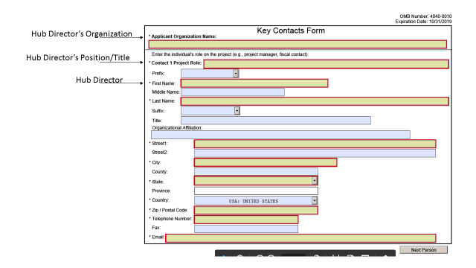

- Project/Performance Site Location(s)
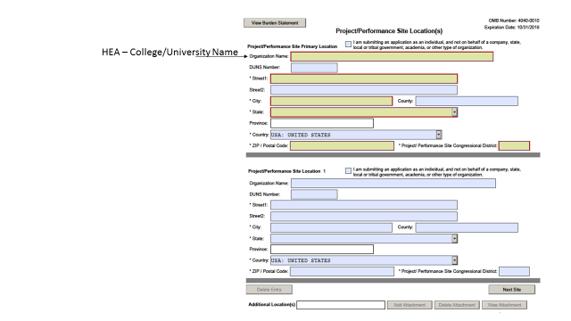

- Attachments Form
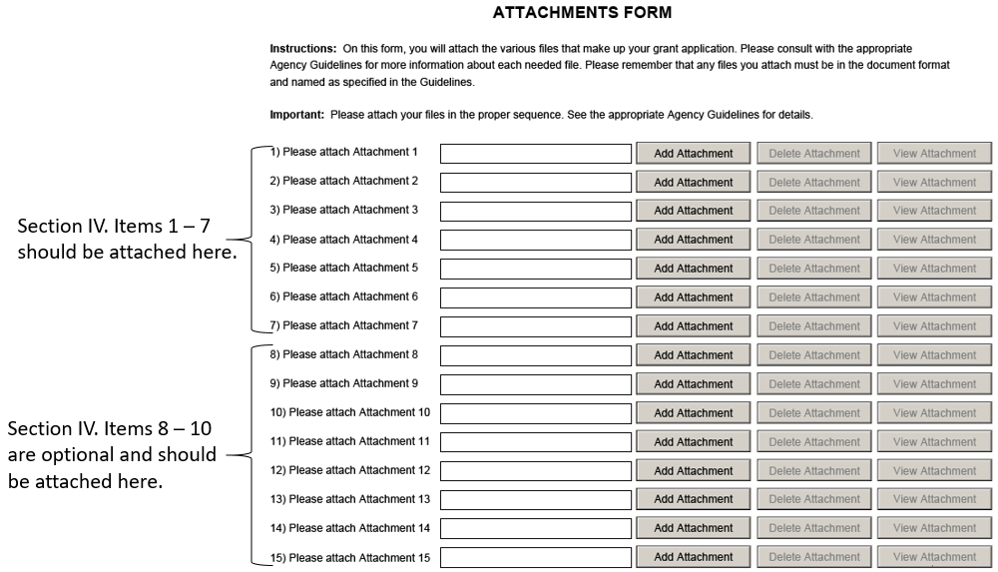

- SF – LLL – This is an optional form, only to be filled out if the HEA applying for this grant is involved in lobbying.

