Attachment 1: PDS performance monitoring plan (PMP)
APPLICANT NAME:
PROGRAM/PROJECT NAME:
PERIOD OF PERFORMANCE:
- M&E NARRATIVE
Describe how you plan to monitor and evaluate performance and outcomes (results) of the proposed project: The narrative should demonstrate the organization’s capacity to implement the PMP proposed and answer the following (limit one page):

- Describe your organization’s capacity to implement the PMP proposed. Which individuals will be responsible for overseeing M&E activities? Briefly note their qualifications and experience. How much of the program’s budget will be allocated towards M&E expenditures?
- What does progress look like for this project and how will you know progress when you see it? What will you observe and measure to know change is happening (e.g. increase in awareness, change in behavior, attitudes, skills)?
- What tools and methods will you use to observe and measure the change you note above (e.g. focus groups, online vs in-person surveys, social media engagement)?
- THEORY OF CHANGE
To demonstrate that your project is measurable by design, please include the intended theory of change. This can be done with (1) a diagram OR (2) in narrative form. Diagrams are preferred, but narratives are also accepted.

Option 1: Diagram:

A Theory of Change diagram is a type of logic model that explicitly illustrates the causal pathways between activities, outputs, outcomes, and objectives. There are many versions. Any version that clearly demonstrates the project’s logical framework is acceptable. Additional guidance is available in the Resources section of the PMP Instructions (Attachment 2). One example is as follows:
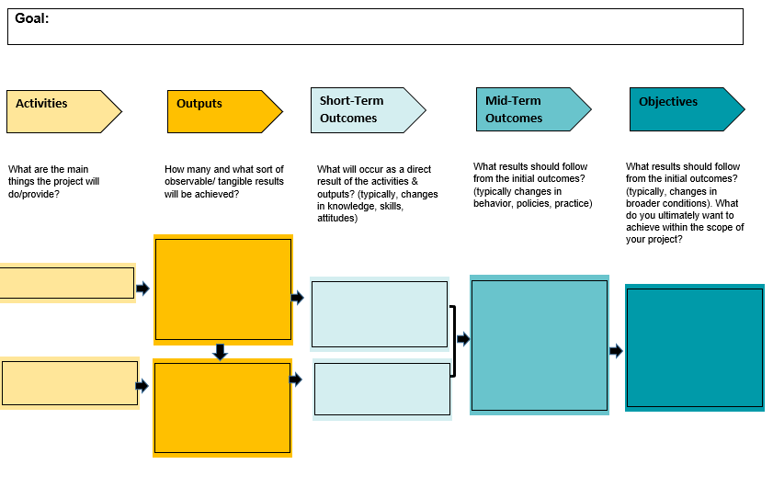
Option 2: Narrative If-Then Statements

A narrative representation of Theory of Change is one, or a series of If-Then statements.
“If x (action/intervention) is completed, then y (result of an action aka. short-term outcomes) which will result in (mid-term outcomes).”

Example: If independent journalists complete a series of training sessions on media literacy, then it will result in higher-quality investigative reporting on sensitive topics such as gender violence, violent extremism, the rights of minorities, etc., which will result in increased government transparency because media professionals will have the knowledge and skills to ...

- PMP DATASHEET:

Please fill in the below PMP. If selected for funding, the recipient will be expected to submit and update this document as part of its required narrative reporting. For most awards, narrative reports are required quarterly. See the “PMP Instructions” for guidance on filling in this datasheet.

Refer to your Theory of Change. For each Outcome and Output, please identify indicators that would demonstrate your progress. Then, establish targets for each indicator across the life of the project. Once approved by PDS, you will update this document and submit with your regular report. For most awards, this will be quarterly. For projects that exceed four quarters, consider using the Excel version of this datasheet, which is available upon request.

GOAL:
AUDIENCE:
PROBLEM STATEMENT:
OBJECTIVE 1:
Activity | Outcome/Output Indicator Description | Data Collection Method | Q1  Month-Month |  | Q2  Month-Month |  | Q3  Month-Month |  | Q4  Month-Month |  | Total Target Achieved | % of Total Target Achieved
 |  |  | Target | Actual | Target | Actual | Target | Actual | Target | Actual
 | Outcome 1.1:
 | Output 1.1.1:
 | Output 1.1.2:
 | Outcome 1.2:
 | Output 1.2.1:
 | Output 1.2.2:
 | Outcome 1.3:
 | Output 1.3.1:
 | Output 1.3.2:
OBJECTIVE 2:
Activity | Outcome/Output Indicator Description | Data Collection Method | Q1  Month-Month |  | Q2  Month-Month |  | Q3  Month-Month |  | Q4  Month-Month |  | Total Target Achieved | % of Target Achieved
 |  |  | Target | Actual | Target | Actual | Target | Actual | Target | Actual
 | Outcome 2.1:
 | Output 2.1.1:
 | Output 2.1.2:
 | Outcome 2.2:
 | Output 2.2.1:
 | Output 2.2.2:
 | Outcome 2.3:
 | Output 2.3.1:
 | Output 2.3.2:
OBJECTIVE 3:
Activity | Outcome/Output Indicator Description | Data Collection Method | Q1  Month-Month |  | Q2  Month-Month |  | Q3  Month-Month |  | Q4  Month-Month |  | Total Target Achieved | % of Target Achieved
 |  |  | Target | Actual | Target | Actual | Target | Actual | Target | Actual
 | Outcome 3.1:
 | Output 3.1.1:
 | Output 3.1.2:
 | Outcome 3.2:
 | Output 3.2.1:
 | Output 3.2.2:
 | Outcome 3.3:
 | Output 3.3.1:
 | Output 3.3.2:

