We received the following question:

Q. Whether a corporation or LLC may apply for a Brookwood-Sago Mine Safety grant?

A. A nonprofit corporation may apply, except a nonprofit entity as described in 26 U.S.C. § 501(c)(4). As provided in the Funding Opportunity Announcement, eligible applicants are the following organizations:

• State governments
• County governments
• City or township governments
• Special district governments
• Public and State controlled institutions of higher education
• Native American tribal governments (Federally recognized))
• Native American tribal organizations (other than Federally recognized tribal governments)
• Nonprofits having a 501(c)(3) status with the IRS, other than institutions of higher
education)
• Nonprofits without 501(c)(3) status with the IRS, other than institutions of higher
education, including labor organizations and unions.

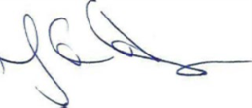

Nancy E. Sloanhoffer
Grant Officer

