Program-Specific Application Instructions for the S424A Non-Construction Budget Form

PLEASE READ THROUGH ALL DIRECTIONS BEFORE BEGINNING THE BUDGET

SECTION A - Budget Summary (It is best to complete Section B first)
1.a. Enter title “THPO Administration Costs”
1.e. Enter the total amount of Federal THPO grant funds going toward Administration Costs.
2.a. Enter title “THPO Operations Costs”
2.e. Enter the total amount Federal THPO grant funds going toward THPO Operations.
3.a. Enter title “THPO Contracts”
3 e. Enter the total amount of Federal THPO grant funds going toward Contracts/Subgrants.

1, 2, 3.f. THPOs are not required to commit matching share (applies to SECTION C as well); however, if matching share is included in the application, the amount of planned matching share must be reported in this field.

Matching share used under this grant is subject to all of the same Federal regulations and audit requirements as Federal share.

SECTION B - Budget Categories (Columns 1, 2 and 3)

Planned budget for grant

All costs must be correctly broken down under columns 1, 2 and 3 based on the type of cost, as described below.

- Column 1 - Administrative Costs
Allowable, reasonable, and allocable costs related to the overall management of activities directly related to finance (accounting, auditing, budgeting, contracting), general administrative salaries and wages (grant administration, personnel, property management, equal opportunity) and other “overhead” functions (general legal services, general liability insurance, depreciation on buildings and equipment, etc.) not directly attributable to specific program areas identified in the grant agreement. All administrative costs reported must be absolutely necessary for project and/or program implementation, such as the cost items identified in the final grant agreement or items otherwise approved in writing by the NPS Awarding Officer (AO).

- Column 2 - Operation Costs
Costs directly attributable to specific HPF program area activities such as national register, survey and inventory, education, review and compliance, etc. These are activities that directly contribute to the accomplishments of the THPO responsibilities, such as:

a. Personnel/Payroll costs for work related to THPO project goals;
b. Equipment/supplies needed for specific THPO projects;
c. Travel expenses for THPO goal-related meetings/conferences.

Note: Some costs may be split between columns. For instance, if a staff person spends time performing both “administrative work” and “operations work,” their salary should be divided between the two columns 1 and 2 based on the percentage of time spent doing each type of work.

- Column 3 - Contracts and Subgrants
Costs paid through contracts to pay for goods or services directly related to the THPO program.

LIMITATION ON INDIRECT AND ADMINISTRATION COSTS - No more than 25% of the entire budget may be applied towards the total of all administrative costs and “indirect costs” (see page 6 for an example).

Budget Object Class Definitions

- Personnel. Direct employees of the THPO/Tribe. Honoraria for Elders providing consultation should go under “other costs.”

- Fringe Benefits. Compensation given in addition to direct wages or salaries, such as medical insurance, paid holidays, etc. This may not exceed what is typically awarded to other Tribal staff.
- Travel. All costs related to travel. Costs must be based on the current Federal fiscal year’s per diem and mileage rates.

- Equipment. Tangible, non-construction, non-expendable personal property, charged directly to the award which has a useful life of more than one year and an acquisition cost of $5,000 or more per unit. *All requests for equipment purchases must be submitted and approved by NPS prior to purchase.

- Supplies. Non-construction items costing less than $5,000 per unit that do not meet the definition of equipment.

- Consultants/Subgrants. Individuals/businesses/organizations providing professional advice or services on the basis of a written agreement for a fee. All consultants must be competitively selected unless written approval is provided by NPS.

- Construction. Construction includes all predevelopment work (plans, studies), construction equipment/supplies/materials/ labor and any other construction-related fees such as inspections, reviews, etc. The total amount in this line item will be further broken down on the SF424c, Construction Budget Form.

- Other. All expenses that do not fit into any of the above categories such as stipends for Elder’s time in consultations, printing, dues, conference fees.

- Indirect Charges: Indirect costs are eligible for reimbursement and must be based on the THPO’s approved indirect cost rate agreement. Indirect costs are costs that are not directly attributable to a specific project or grant.

The total of all indirect costs plus all administration costs (Column 1) may not be more than 25% of the grant award.

- Program Income. Gross income earned by a grantee that is directly generated by a grant supported activity, during the period of the grant agreement (or received by a contractor/subgrantee during the period of their HPF funded agreement). Program income must be used before federal funds.

SECTION C - Complete section only if matching share will be used (THPOs are not required to include matching share. All matching share funds must comply with federal, agency and program grant requirements including audit requirements.

SECTION D and E – THPOs do not have to complete these sections

SECTION F – Other Budget Information

Fields 21 and 22 - Enter the total amount of Direct Charges and Indirect Charges.

Field 23 - List all equipment planned for purchase under the grant.

Sample Completed Application SF424a

(as formatted on GRANTS.GOV)

Page 1 of SF424a
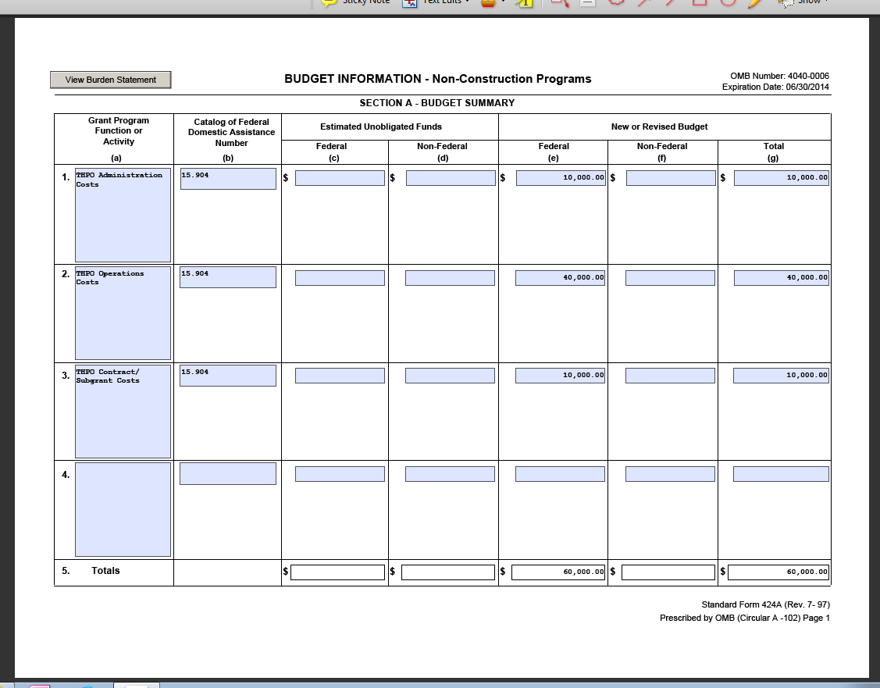

Page 2 of SF424a
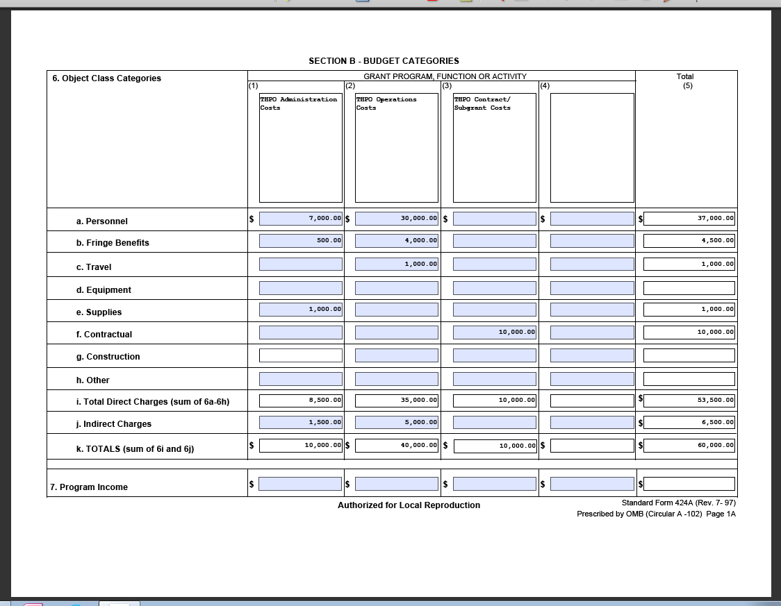
The total of Column 1, line i - total direct costs + total column, line j - total indirect costs) may not be more than 25% of the total grant award (total column, line k)

Page 3 of SF424a
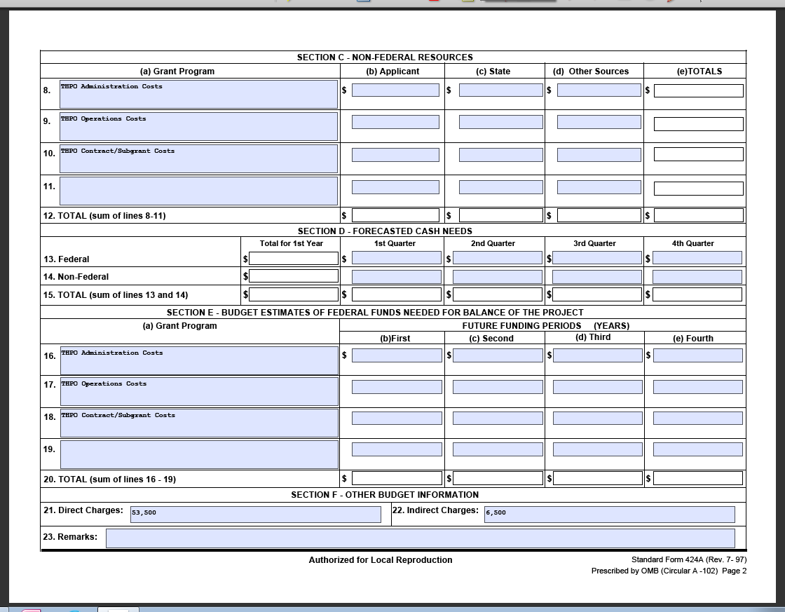
Sections C, D and E do not have to be completed for THPO HPF grants.

