AID-RFI-612-14-00001
Issuance Date: December 18, 2013
Closing Date: January 20, 2014
Closing Time: 17:00 Local Malawi Time
Subject: Request for Information (RFI)
USAID/Malawi’s Fisheries Integration of Society and Habitats (FISH) Activity

The United States Agency for International Development (USAID) is seeking comments on a draft program description for a planned new activity, Fisheries Integration of Society and Habitats (FISH), to be funded by USAID/Malawi. The Mission plans to issue a solicitation for FISH within the next few months. The program description presents the current draft objectives and key elements of the activity. The draft does not constitute a request for applications, which will come later through a separate process. USAID/Malawi may significantly revise this proposed new activity and planned solicitation resulting from the comments received and further internal discussions.
By issuing the draft for comment USAID/Malawi aims to consult with the broad community of actors involved with climate change adaptation, biodiversity conservation, and fisheries in Malawi. Your comments are requested to help refine the program description to ensure maximum development impact, sound coordination with existing activities, and alignment with the Government of Malawi’s top priorities. Please ensure your comments are concise and specific to information included within the draft program description. While there are no limits on the length of submissions accepted, we value concise, issue-specific responses with reference to page and section numbers in the draft program description.
Please send your comments and questions to Adel Yamak at ayamak@usaid.gov and Rajab Banda at rabanda@usaid.gov no later than the closing date shown above.
Draft Program Description for Public Comment
Fisheries Integration of Society and Habitats (FISH)

C.1. Introduction
The Fisheries Integration of Society and Habitats (FISH) activity will increase social, ecological, and economic resilience to climate change and improve biodiversity conservation through sustainable fisheries co-management. FISH will focus on a key cross section of Malawian fisheries located in the Upper Shire Water Basin, the Southern shore of Lake Malawi, and the smaller lakes Chilwa, Malombe, and Chiuta. Interventions will achieve the following outputs:
Output 1. Utilization of science, analysis, and information for decision making increased
Output 2. Enabling environment for sustainable fisheries management enhanced
Output 3. Integration with other activities strengthened to leverage mutual benefits
Output 4. Adoption of fisheries management measures that support climate resilience and biodiversity conservation increased
Taken together, improved knowledge (Output 1) will inform systems with enhanced capacity (Output 2), integrated (Output 3) within a broader development context, and action will be catalyzed (Output 4) towards the overall goal of increased social, ecological, and economic resilience to climate change and improved biodiversity conservation through sustainable fisheries co-management.
C.2. Background
C.2.1. Development Problem
Approximately 22 percent of the surface area of Malawi is covered by freshwater ecosystems, and fishing has long defined the people and culture of Malawi. In a chronically food insecure country, fish remains the nation’s most important source of animal protein (FAOSTAT, 2009), and the fisheries sector supports livelihoods, making up approximately 4 percent of Gross Domestic Product (FAO, 2005) and employing over 500,000 people (GOM, 2009). Malawi’s freshwater ecosystems are also a global jewel of biodiversity, supporting more than 1,000 different fish species and approximately 14 percent of global freshwater fish biodiversity (EAD, 2010). With over 800 species, of which 99 percent are endemic, Lake Malawi has the most bio-diverse fish population of any lake in the world (EAD, 2010 and Johnson et al, 2012).
Unfortunately, as Malawi’s population grows and as its climate changes, these unique freshwater ecosystems face mounting threats. Historically, species such as nchila (Labeo mesops) which made up the majority of the catch in Southern Lake Malawi in the 1950s, became locally extinct by the 1970’s due to over-exploitation of stocks (Kasulo and Perrings, 2006). Meanwhile catch per unit effort decreased fourfold as fisherfolk had to work harder to catch smaller fish (Kasulo and Perrings, 2006). The most valuable fish species in recent years, namely three species of the Oreochromis genera collectively called “chambo,” have shown similar dramatic declines in catches since the 1980s, due primarily to excessive fishing pressure (Bell et al. 2012). With the combination of over-fishing, shrinking mesh sizes for nets, degradation of spawning grounds and nursery areas, and limited adherence to sustainable management practices, 102 Malawian fish species are listed as endangered (EAD, 2010). The estimated cost of unsustainable fishing practices in Malawi, just in terms of catch and yield and not including other economic values such as biodiversity, is $28 million annually (Yaron et al, 2011).
Climate change poses additional threats to Malawian fisheries. Predicted increases in temperature, coupled with increased rainfall variability will likely affect lake levels, circulation patterns, water chemistry, stream flows, and siltation, with concomitant impacts on fish species, habitats, spawning areas, and of course, fishing communities (Wood and Moriniere, 2013). For example, chambo biomass is closely correlated with mean lake height (Bell et al. 2012), suggesting that lower lake heights predicted under climate change would lead to further declines in chambo populations. The most striking climate vulnerability, however, is Lake Chilwa, which has typically provided approximately a quarter of Malawi’s annual catch of fish. With a maximum depth of just 5 meters, Lake Chilwa dried out completely in 1968 and 1995, and predicted changes in climate will likely increase the frequency of these drying events, with potentially devastating impacts on surrounding fishing communities (Wood and Moriniere, 2013).
In spite of its importance for both livelihoods and global biodiversity, the knowledge and capacity base for decision making and management in Malawi’s fisheries sector is limited. The Department of Fisheries has been unable to carry out regular stock assessments (Njaya, 2013), and the indicators that have been tracked may not be appropriate for diverse fishing practices within a diverse ecosystem (Zwieten et al, 2011). Fisheries curriculum at Malawian universities is also limited, and understaffed programs rely on faculty who are not sufficiently trained (Kapute, 2008). These monitoring, research and educational capacity constraints, combined with limited support for extension or other forms of dialogue with fishing communities, translate to restricted flow of information between stakeholders.
Efforts to improve fisheries governance to date have yet to overcome many of the challenges that the sector faces (Jamu et al, 2011). As part of a broader decentralization process, efforts were made in the 1990s and early 2000s to decentralize management and decision-making in the fisheries sector, giving more responsibility to District Governments, Area Development Committees (ADCs), Village Development Committees (VDCs), and specifically for fishing communities, Beach Village Committees (BVCs). Unfortunately, however, blurred power dynamics with Traditional Authorities (TAs), limited representation of fisherfolk in BVCs, and unclear decision-making processes and authorities, left fisherfolk feeling disenfranchised, and as such, many of the rules that were adopted under the decentralized framework have been simply ignored, leaving de facto, open access, unregulated fisheries (Hara, 2008 and Njaya et al, 2011). Women have been particularly underrepresented in decision making for the sector in spite of the fact that they have traditionally been responsible for the majority of fish processing and trade (Hara, 2008).
Malawi’s freshwater ecosystems and fisheries cannot be looked at in isolation from their relation to other sectors. Deforestation, agricultural expansion, erosion, and natural resource degradation throughout the watershed, can impact fisheries through altering stream flows and sediment loads as well as habitats and spawning areas. Related to that, perhaps the largest underlying threat to freshwater ecosystems and the people who depend on them is Malawi’s rapid population growth, meaning that family planning along with education and girls’ empowerment could be powerful, indirect tools for leading to more resilient fisheries. Within this broader context, integrated activities will be needed to address the interests of diverse stakeholders, as well as the social, ecological, economic and external factors threatening freshwater ecosystems and the people who depend on them (Jamu et al, 2011).
C.2.2. Statutory Requirements
The FISH activity represents a primary implementing mechanism under the Adaptation Pillar of the President’s Global Climate Change Initiative for USAID/Malawi. Subject to the availability of funds, it is anticipated that the funding from the Adaptation Pillar will comprise approximately 50 percent of the FISH activity. Funding for Adaptation activities must meet all statutory requirements and align with guidance in USAID’s Global Climate Change Strategy. In particular, direct Adaptation funding should have an explicit, primary climate change adaptation goal or objective and should address the following priority areas, as appropriate:
- Strengthened science and analysis to inform decision making in topics sensitive to climate
- Improved governance to address climate-related risks
- Piloting, evaluating and implementing effective adaptation strategies and actions to address climate-related risks
The FISH activity also represents a primary implementing mechanism under the Congressional Biodiversity Earmark for USAID/Malawi. Subject to the availability of funds, it is anticipated that the remaining 50 percent of the budget for FISH will come from the Biodiversity Earmark. All Biodiversity Earmark-funded activities must align with USAID’s Biodiversity Code. They must:
- Have an explicit biodiversity objective
- Be identified based on an analysis of threats to biodiversity
- Monitor associated indicators for biodiversity conservation
- If site-based, have the intent to positively impact biodiversity in biologically significant areas.
C.2.3. Relation to Broader Mission Efforts
The FISH activity fits into USAID/Malawi’s larger Country Development and Cooperation Strategy (CDCS). The overall goal of the CDCS is to improve Malawian’s quality of life, and FISH primarily supports this objective through Intermediate Result 2.1 “Resiliency to Climate Change Strengthened.” FISH also directly supports the following cross-cutting Sub-Intermediate Results (SIRs):
- Cross cutting SIR 1: Capacity of institutions improved
- Cross cutting SIR 3: Policy and systems strengthened
- Cross‐cutting SIR 4: Positive behaviors adopted
USAID/Malawi’s CDCS emphasizes integration of activities across sectors, through what has been called the “3 C Approach” which includes:
- Co-locating interventions to the extent that it is sensible;
- Coordinating better within USAID and with other Development Partners (DPs), and
- Collaborating to foster linkages among implementing partners and the DPs to improve results,
and sustainability.
Through this approach USAID hypothesizes: if assistance is integrated then development results will be enhanced, more sustainable, and lead to achievement of our CDCS goal: Malawians’ quality of life improved.
The FISH activity has therefore been intentionally co-located in the CDCS focus districts of Balaka and Machinga, where there will be ample opportunities for better coordination and collaboration across activities and with DPs (see section C.7). The districts of Mangochi and Zomba were also selected because they are contiguous to Balaka and Machinga and exemplify the challenges that FISH aims to address (see Figure 2, page 12).
USAID/Malawi’s Mission-wide project titled “Tomorrow’s Generations Empowered: Trade, Health, Environment and Reading (TOGETHER)” begins to operationalize the CDCS and test the hypothesis that integrated programs will maximize development results. FISH is one activity that falls under the larger TOGETHER project.
C.3. Scope
The Fisheries Integration of Society and Habitats (FISH) activity will increase social, ecological, and economic resilience to climate change and improve biodiversity conservation through sustainable fisheries co-management. Interventions will focus on increasing utilization of scientific information, enhancing the enabling environment, achieving greater impact through integration with related development efforts, and increasing adoption of resilient fisheries management measures.

C.4. Objectives
The results framework for FISH, including how FISH fits into USAID/Malawi’s broader CDCS, is presented in Figure 1 below. The two primary objectives for FISH of (1) increasing resiliency to climate change and (2) improving biodiversity conservation reflect the principle funding sources of the activity. These objectives are integrated through improving sustainable fisheries co-management, and it is assumed that the objectives complement one another (increasing resilience to climate change will improve biodiversity conservation, and, alternatively, improving biodiversity conservation will increase resilience to climate change). Note that “Resiliency to climate change strengthened” is also IR 2.1 under the CDCS. Together, the dual activity-level objectives support the broader Development Objective (DO) of “Sustainable livelihoods increased” and the CDCS goal of “Malawian’s quality of life improved.”
Figure 1: Results Framework for FISH
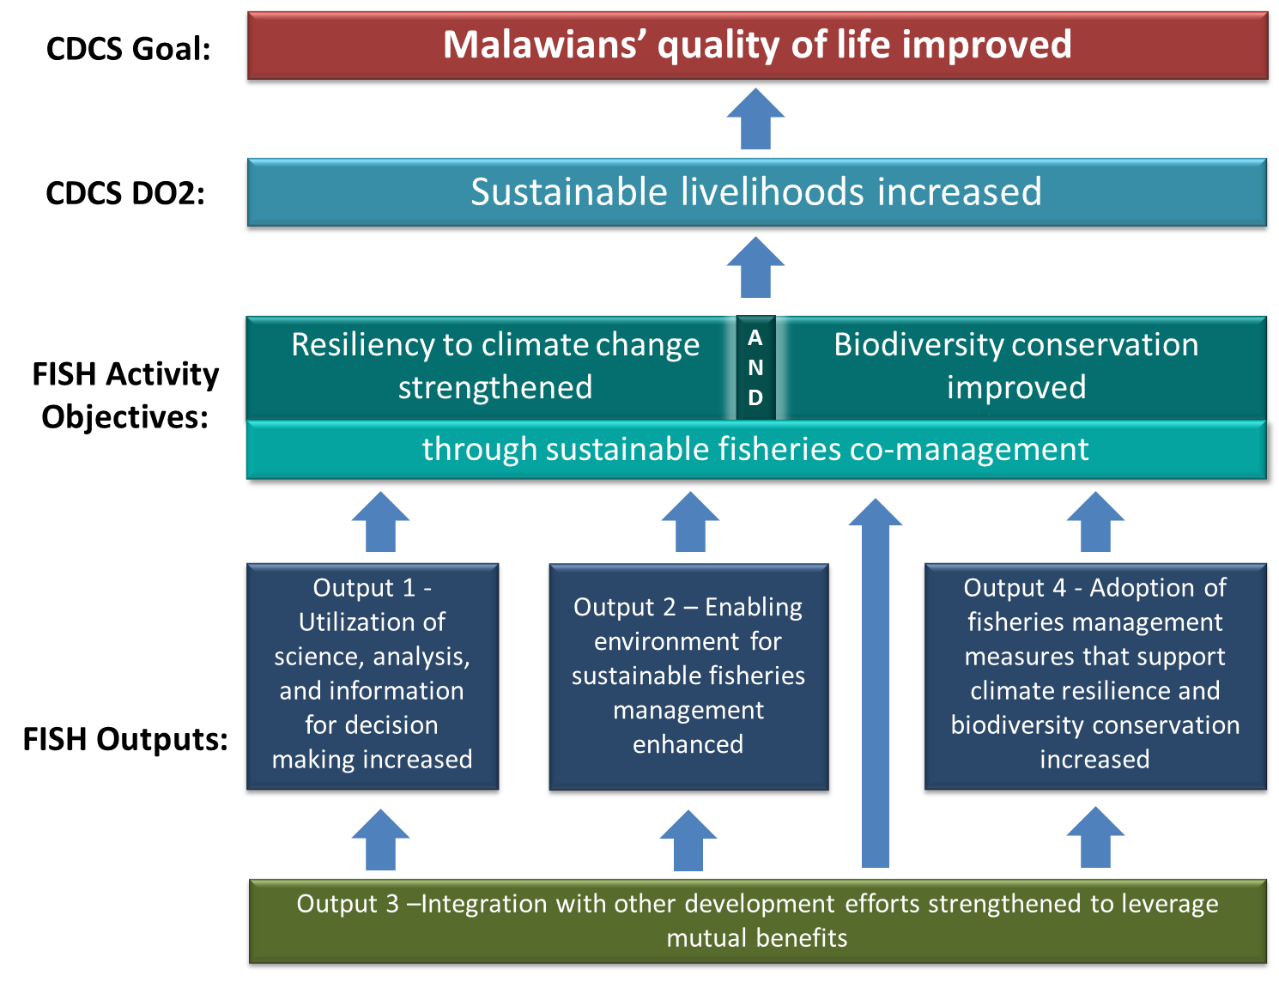
To achieve the overall objectives of FISH, the four Outputs, illustrated in the Results Framework, will be required. The development hypothesis is:
If improved knowledge (Output 1) informs systems with enhanced capacity (Output 2) which are integrated within a broader development context (Output 3), and if action is catalyzed towards sustainable fisheries co-management (Output 4), then social, ecological, and economic resilience to climate change as well as biodiversity conservation will be improved.
In short, the hypothesis states that focused knowledge, capacity, integration, and action will achieve the objectives of FISH. In turn, the objectives of FISH should then lead to supporting DO2 and the overall goal of the CDCS.
C.5. Results
Each of the Outputs is described in more detail below, including Sub-Outputs which support each Output. Note that at a minimum, the types of interventions that achieve this results framework must meet initiative and earmark requirements. To achieve greater impact, recipients may propose alternatives at the sub-output level based on lessons learned through adaptive management and through consultation with USAID/Malawi. Recipients must ensure the feasibility and appropriateness of their implementation process, sequence, and expected results given the current context in Malawi, and they should utilize an approach that would ensure ownership of the results by stakeholders themselves and embody adaptive management to respond to stakeholder priorities. Note that the outputs described here are not listed in order of importance or expected value of investment.
Output 1. Utilization of science, analysis, and information for decision making increased – A focus on climate-resilience and biodiversity conservation in the fisheries sector should be prioritized, while consideration could also be given to related issues such as resource management, population dynamics, gender equity, and women’s empowerment where justifiable within initiative and earmark funding parameters. Recipients should translate science, analysis and information into action, instilling a commitment to learning, and improving the uptake of science and analysis in individual, management, and policy decisions. Evidence should be produced to demonstrate the performance of information services and decision support tools, as well as their impacts on development decisions.
Sub-Output 1.1. Access to science, analysis, and information improved - This Sub-Output is envisioned to address knowledge gaps, systems of gathering and analyzing data, linking supply of information with demand, and processes for sharing information. Data collection and research systems should be better targeted for decision-making needs from the local level to the level of national policy. The recipient should ensure long term sustainability of any proposed changes to data collection, analysis, and knowledge management systems within likely budget and capacity scenarios.
Sub-Output 1.2. Understanding of threats to biodiversity and options for conservation deepened – A broad Environmental Threats and Opportunities Assessment (ETOA) was recently completed for Malawi (Johnson et al. 2012). However, further interventions should be based on a deeper understanding of threats to biodiversity within freshwater ecosystems specifically to ensure strong alignment with USAID’s Biodiversity Code.
Sub-Output 1.3. Understanding of climate adaptation options for fisheries strengthened – A comprehensive Malawi Climate Change Vulnerability Assessment that included fisheries was recently completed for Malawi (Wood and Moriniere, 2013). However, a deeper understanding of likely climate change impacts and adaptation options for freshwater ecosystems, the watersheds that influence them, and the communities that depend on them should inform FISH interventions in line with Adaptation funding guidance.
Output 2. Enabling environment for sustainable fisheries management enhanced– Science, analysis, and knowledge management alone will not translate to reaching the overall objectives of the activity. Relevant institutions will also need to have the mandate, authority, and capacity to act on the new information. Under Output 2, recipients should achieve consensus, trust and shared vision among stakeholders around appropriate objectives for sector reform, building the necessary social capital (constituency), stakeholder motivation (commitment), and capacity at all levels to give reform efforts the best possible chance for long term sustainability.
Sub-Output 2.1. Legal framework for sustainable fisheries management improved – An improved legal framework should strengthen the legal basis for practical, enforceable, culturally acceptable, and sustainable fisheries management systems. Recipients will need to work closely with the GOM and other stakeholders to achieve Sub-Output 2.1.

Sub-Output 2.2. Transparency, representation and accountability in decision-making advanced – In addition to improving legal frameworks, it is important to ensure that policies are implemented. This is intended to ensure that fisherfolk, women involved in the sector, and other previously underrepresented groups are involved in decision-making through transparent processes that enable both upward and downward accountability.

Sub-Output 2.3. Institutional capacities strengthened – Enhanced capacity could include human capacity through education and training; organizational capacity; and/or technical capacity of a range of institutions. Recipients should prioritize specific institutions and types of capacity that are most pertinent for achieving the objectives of FISH.

Output 3. Integration with other development efforts strengthened to leverage mutual benefits – In line with the focus on integration within USAID/Malawi’s CDCS, the recipient should exemplify co-location, coordination, and collaboration with the GOM, other DPs, and other USAID/Malawi activities. Where it supports the activity’s objectives, the recipient should leverage and support concomitant investments in fisheries, food security, forestry, education, water resource management, health, and others. In an ever-evolving set of contexts, the recipient should practice adaptive management, building on the work of others while filling gaps and addressing bottlenecks in achieving strengthened resilience to climate change and improved biodiversity conservation. The aim of integration should be overall efficiency gains, including: reducing duplication or parallel structures, establishing synergies between investments, and adjusting to participant time and resource constraints (i.e. avoiding “participation fatigue” where multiple projects are active in the same communities). Recipients should implement a clear strategy to proactively create synergies and capitalize on windows of opportunity.
Sub-Output 3.1. Coordination of development efforts improved among DPs, the GOM, and other stakeholders – Illustrative examples of coordination efforts could include harmonizing efforts in research, decentralization of governance, or extension efforts with other sectors; developing functional linkages between site-based activities related to FISH; or many others. More information on coordination with host country counterparts and other implementing partners can be found in section C.7.
Sub-Output 3.2. Functional linkages to other USAID programs developed – USAID/Malawi is concentrating multiple activities in the districts where FISH operates, and where practical, the recipient must seek avenues for leveraging mutual impacts. As an illustrative example, the upcoming activity titled Protecting Ecosystems and Restoring Forests in Malawi (PERFORM) is expected to do site based work in the focus districts of the CDCS, and PERFORM’s efforts towards sustainable management of forests could be aligned with site-based work in catchments under FISH to support protection of fish habitats. Likewise, the recipient may pursue linkages with planned activities in decentralization and local governance or ongoing activities in family planning, Food for Peace, education, Feed the Future, or others with support and guidance from the Mission. More information on integration with other USAID/Malawi activities can be found in section C.7.
Output 4. Adoption of fisheries management measures that support climate resilience and biodiversity conservation increased – The first three Outputs lay much of the groundwork that can lead to increasing adoption of sustainable fisheries management. None the less, the recipient needs to play a catalyzing role that can expand uptake of behaviors and technologies that increase resilience to climate change and improve biodiversity conservation. Emphasis should be placed on innovation, piloting and evaluating the effectiveness of adaptation strategies through a learning agenda linked with Output 1. Interventions should be based on sound considerations of feasibility, sustainability, and relevant costs and benefits for beneficiaries.
Sub-Output 4.1. Sustainable fishing practices supported and evaluated – Sustainable fishing practices, as defined here, are those which successfully blend ecological principles, cultural acceptability, economic pragmatism, reduced threats to biodiversity, and resilience to climate-related risks. Practices should be evidence based and illustrative examples could include supporting managed access or tenure arrangements, enforcement of regulations, improved post catch handling, or many others. FISH may also need to address key bottlenecks to increasing adoption of improved practices (e.g. needs for training, access to finance, basic inputs, etc.).

Sub-Output 4.2. Alternative, climate-resilient livelihood options stimulated and evaluated – Alternative and/or complementary livelihoods could reduce fishing pressure, and expanding viable alternatives to fishing will be necessary to avoid continual over-exploitation of fishing resources as community populations continue to grow. Likewise, where fishing areas may dry up completely on a periodic basis, communities will need to expand their livelihood options to adapt to predicted changes in climate.

Sub-Output 4.3. Improved natural resource management practices supported and evaluated in key catchment areas – An important component of promoting biodiversity and adapting to changes in climate will be sustainably managing catchment areas. Maintaining environmental flows and water quality can lead to more resilient and productive wild fisheries.

In addition to the Outputs and Sub-Outputs described above, the recipient must emphasize the following five cross cutting themes:
- Sustainability – Previous efforts to improve the fisheries sector in Malawi have been unable to ensure long term sustainability, and across many sectors, a mentality of donor-dependence has taken root. Interventions under FISH should have a clear exit strategy that ensures that structures of knowledge sharing, management and good governance will continue beyond the project support period. Ensuring sustainability will also depend on practicing adaptive management, building in flexibility for the activity to evolve as it meets changing needs and priorities.
- Private sector engagement – Though small artisanal fisheries comprise the majority of the sector in Malawi, there are several medium sized and a few large scale, commercial fishing operations. The recipient should actively seek to work with the private sector for mutually beneficial development solutions.
- Local empowerment – FISH should support local ownership and leadership, directly collaborating with the GOM and other key stakeholders and utilizing existing governance structures where possible and practical. Participatory processes should be robust, allowing stakeholders to own and redefine objectives in order to ensure buy-in and in turn, sustainability. In line with the Local Solutions Initiative of USAID Forward, FISH should also actively utilize the talents of local organizations to implement cost effective interventions. Likewise, FISH should seek to build the technical capacity of these organizations for longer term development results. The recipient should identify and address capacity gaps that will affect the outcome of the activity and sustainability after the implementation period.
- Gender –In the case of fisheries, men traditionally do the majority of fishing, but women are more actively engaged in processing and marketing the fish. In spite of women’s important roles in the sector, they are largely underrepresented in governance and decision making processes. All interventions under FISH should carefully consider gender dynamics and aim to promote gender equity and female empowerment in line with Agency policy.
- Innovation – The FISH activity should embrace new and locally appropriate technologies, strategies, or opportunities that have potential for transformative impacts. As mentioned previously, the recipient should implement a clear learning agenda, especially with regard to innovation.
Monitoring and Evaluation
The FISH activity will need to have a strong Monitoring and Evaluation Plan to track progress towards its objectives and results. The list of indicators below includes those which are required or required as applicable, and the results and objectives which they may track are included in parenthesis. All of the indicators listed below are either mandatory under USAID/Malawi’s CDCS or under initiative and earmark guidance. Those which are listed as “required” are linked closely with the main objectives of the FISH activity and therefore must be reported on. Those that are “required as applicable” must be included only in instances where they represent a clear mark of progress towards results and objectives in alignment with the recipient’s approach. Other standard indicators and/or carefully chosen custom indicators, based on the recipient’s interventions, may be necessary in order to mark progress towards each result and objective.
Required Indicators for Reporting:
- Number of communities implementing risk reducing practices to improve resiliency to climate change increased from __ to __ (CDCS IR 2.1)
- Number of stakeholders with increased capacity to adapt to the impacts of climate variability and change as a result of USG assistance disaggregated by
  - Implementing risk-reducing practices/actions to improve resilience to climate change (Sub-Output 4.1 – 4.3)
  - Using climate information in their decision making (Output 1)
- Number of farmers/fishers applying improved management practices (CDCS SIR 4)
- Number of hectares in areas of biological significance and/or natural resource showing improved biophysical conditions as a result of USG assistance (Biodiversity Conservation Objective)
- Number of hectares of biological significance and/or natural resources under improved natural resource management as a result of USG assistance (Biodiversity Conservation Objective)
Required as Applicable Indicators
- Number and type of new technologies tested in communities (CDCS SIR 2)
- Number of people receiving USG supported training in natural resources management and/or biodiversity conservation (Sub-Output 4.1-4.3)
- Number of people with increased economic benefits derived from sustainable natural resource management and conservation as a result of USG assistance (Sub-Output 4.1-4.3)
- Number of institutions with improved capacity to address climate change issues as a result of USG assistance (CDCS SIR 1)
- Household expenditures increased from __ to __ (CDCS DO2)
- Improved capacities of subnational units to provide key infrastructure and services (CDCS IR 1.1)
- Number of people with increased economic benefits derived from sustainable natural resource management and conservation as a result of USG assistance (Sub-Output 4.1 – 4.3)
- Number of people receiving training in Global Climate Change as a result of USG assistance (Output 1, Sub-Output 1.1, 1.3, 2.3, 4.1 – 4.3)
- Number of days of USG funded technical assistance in climate change provided to counterparts or stakeholders (Sub-Output 1.2, 1.3, 2.3, 4.1 – 4.3)
- Percent of assisted communities or organizations adopting improved technologies (CDCS SIR 2)
Geographic Information Systems (GIS)
USAID Malawi is currently rolling out a Mission wide GIS to support informed decision making and increase the use of evidence to affect decisions and resource allocations across the portfolio. This will include elements of data management, standardization and collection using global positioning system hand held receivers (GPS Units) to capture geo-referenced location data of activities, etc. All new awards (where appropriate) are required to collect and provide spatial data. The use of GIS for spatial data development and reporting should be included.

C.6. Place of Performance
Figure 2: Map of FISH place of performance
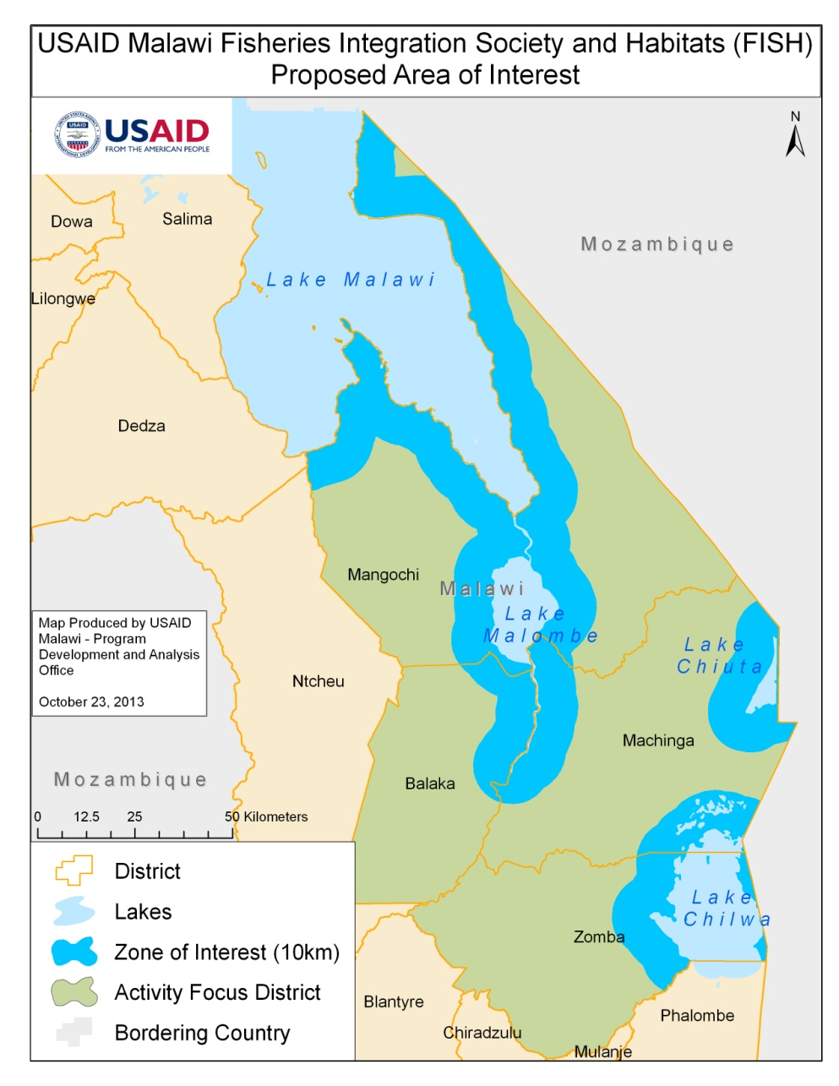
Figure 2 illustrates the general focal geography of FISH. The FISH activity will focus in Southern Malawi in an area that includes a cross section of key freshwater ecosystems, including the Southern shore of Lake Malawi, the North Shire River Basin, and the smaller lakes Malombe, Chilwa, and Chiuta. Taken together, these ecosystems broadly represent and exemplify Malawi’s challenges in fisheries management. With these ecosystems as the focus, FISH will be primarily implemented in the districts of Mangochi, Machinga, Balaka, and Zomba. Some interventions may extend beyond the focal area, particularly those in research or policy which may have national implications.
It would be unrealistic to assume that FISH can successfully address all fisheries related challenges in a comprehensive way within this general focus geography. Though some interventions may cover the entire focal geography, it is anticipated that focused interventions would target areas where they can have the greatest impact, with careful consideration of the focal geography of other ongoing and planned activities.
C.7. Coordination with Host Country Counterparts and other Implementers
C.7.1. GOM Colocation, Coordination, and Collaboration
FISH is well aligned with priorities of the GOM. Malawi’s Growth and Development Strategy (MGDS II) recognizes that natural resources form a principal source of social wellbeing and economic development in Malawi, and the National Adaptation Program of Action (NAPA) identifies sectors that are affected by climate change, including agriculture, health, energy, fisheries, wildlife, water, forestry, and gender. The forthcoming National Climate Change Policy identifies climate change impacts to fisheries including drying up of lakes and temperature changes affecting aquatic life. In response to declining fish stocks and in anticipation of increasing stresses, the government prioritizes strategies to promote a harmonized ecosystems approach in fisheries management, including: protection of water resources and good catchment management; aquaculture and technologies that reduce loss; improved collection and dissemination of climate and weather data for effective climate change adaptation; and research on fish species and aquaculture technologies.
The recipient must collaborate with multiple Ministries, Departments, and decentralized structures with the GOM. Existing structures should be utilized whenever possible, avoiding duplication of efforts or the creation of parallel structures. Close collaboration with the Fisheries Department, housed in the Ministry of Agriculture and Food Security, will be critical to successful interventions in fisheries. The Ministry of Environment and Climate Change Management (MECCM) is the central Ministry through which climate-related planning and programming takes place, and as such, it is a primary stakeholder in the success of USAID/Malawi’s climate change programming. The Ministry of Irrigation and Water Development overseas the National Water Development Program, which includes a suite of activities that will also be relevant to interventions under FISH. As stated previously, it is expected that the recipient will also work through decentralized structures, building on ongoing efforts wherever practical and promoting local leadership, ownership, transparency, and accountability among appropriate stakeholders.
C.7.2. DP Colocation, Coordination, and Collaboration
FISH was also designed in coordination with other DPs. Priority sectors and areas of intervention were chosen to fill needed gaps and complement other ongoing or planned programs. Listed and described below are ongoing development efforts funded by DPs:
Norwegian Ministry of Foreign Affairs (NOR) –NOR is funding the Lake Chilwa Basin Climate Change Program (LCBCCP) implemented by WorldFish in partnership with Leadership for Environment and Development (LEAD), The Forestry Research Institute of Malawi and the University of Malawi. Due to the grave challenges that face Lake Chilwa, including severe erosion and potential drying up under climate change, NOR welcomes additional support in the basin and collaboration with LCBCCP.
Department for International Development (DFID) – Multiple DPs, with DFID in the lead, are supporting the Enhancing Community Resilience Program (ECRP). The goal of the program is to achieve sustainable, disaster-resilient communities through community-based best practices, public awareness and policy change. The intervention area is broad but does include the Machinga district in the FISH intervention area, necessitating appropriate coordination.
European Union (EU) – The EU is also developing a EUR 8 million Global Climate Change Alliance (GCCA) project that is largely aligned with ECRP. The overall objectives are to 1) contribute to climate change mainstreaming at regional and district levels and 2) increase the resilience of vulnerable communities to climate variability and change. FISH should coordinate with GCCA to ensure alignment and synergies.
United Nations Development Program (UNDP) – In collaboration with the GOM, UNDP is taking a lead role in terms of national climate change policy, alignment, and coordination. UNDP also manages a Sustainable Land Management (SLM) activity in the Shire Basin, including district level planning in Balaka and Zomba. FISH should collaborate with UNDP, especially with regards to interventions that are policy-based, national in scope, or relevant to district planning through the SLM activity.
Icelandic International Development Agency (ICEIDA) – ICEIDA has worked on district level development focused in Mangochi, including support to the fisheries sector. FISH should build on this work and draw from lessons learned.
Japan International Cooperation Agency (JICA) – JICA is supporting medium scale irrigation schemes within the FISH intervention area.
World Bank – The Shire River Basin Management Project is a $125 million project focused on basin planning, management, and infrastructure throughout the Shire Basin. Coordination, especially with respect to national policy and guidelines, will be necessary to ensure alignment of activities. Likewise, the Shire Basin Management Project will include extensive hydro-meteorological modeling, and FISH should avoid duplication while finding synergies with efforts supported by the World Bank.
Millennium Challenge Corporation (MCC) – A 5-year $350 million compact for Malawi through MCC focuses on sustainable increases in power generation, with an emphasis on supporting improved hydropower generation on the Shire River. Within the compact, MCC is planning to support natural resource management efforts such as agroforestry and reforestation through either a grant mechanism or development of a trust. These efforts could support the success of FISH if aligned accordingly.
USAID/Malawi Colocation, Coordination, and Collaboration
With the focus on integration of activities under USAID/Malawi’s CDCS and the expected result of greater linkages to other activities developed, implementers of the FISH activity should be highly cognizant of how the program is embedded within and supportive of broader development goals through USAID/Malawi. Listed below are some activities that are particularly relevant:
Local Capacity Development Activity (TBD) – Any local implementing partners who form part of the implementation of FISH, either through sub-awards or direct partnership, will be eligible for capacity building support through the Supporting the Efforts of Partners (STEPS) activity. This activity will provide capacity building training in areas of organizational development such as improving financial management, monitoring and reporting, human resources development, and addressing other capacity gaps. The recipient must facilitate participation of any sub partners under the FISH activity into STEPS for capacity building and training.
Integrating Nutrition in Value Chains (INVC )- The INVC Feed the Future program promotes value chain development of soy, groundnuts, and dairy, including supporting conservation agriculture interventions that can have positive, water-related outcomes that increase resiliency. Within the FISH geography, INVC operates in Balaka, Machinga, and Mangochi.
Wellness and Agriculture for Life Advancement (WALA) – The WALA Title 2 Food for Peace program supports an integrated development program that includes watershed rehabilitation and small scale irrigation in select catchments. Though WALA comes to an end in 2014, a follow on Food for Peace activity is planned that will likely be active in the CDCS focus districts of Balaka and Machinga.
Protecting Ecosystems and Restoring Forests in Malawi (PERFORM)(TBD) – A Climate Change Sustainable Landscapes and Enhancing Capacity for Low Emissions Development activity, PERFORM is under design in tandem with FISH and will focus on sustainable management of forests. This activity should be closely coordinated with FISH as there may be mutually beneficial outcomes (e.g. targeting forestry and agroforestry efforts where they can have a positive impact on water resources).
WASH activities – Ongoing WASH activities support GOM efforts in water service delivery to rural and peri-urban areas to protect existing water sources and sustainable development of new sources through, for example, investments in the construction of WASH hardware and community engagement in hardware maintenance.
Family Planning and Sexual and Reproductive Health Program (FP/SRH)- USAID/Malawi has worked alongside Malawi’s Ministry of Health (MOH) to strengthen its FP/SRH Program through a comprehensive approach that includes targeted service delivery, supply chain strengthening, advocacy and policy interventions. USAID’s program raises awareness of the impact of rapid population growth through national and district level advocacy interventions that target communities, religious leaders and decision makers to increase support of voluntary FP/SRH. Through building linkages to FP programs, the recipient may ensure the long term sustainability of interventions targeting climate change adaptation and biodiversity conservation.
USAID/Mozambique – In an adjacent and directly related program in Mozambique, USAID has worked in partnership with the government, the World Wildlife Fund, and Coca-Cola Co. to protect the species and natural habitats on Lake Malawi (called Lake Niassa in Mozambique). The establishment and protection of the Lake Niassa Reserve also supports fishermen’s livelihoods and lays a path for broad-based growth in sustainable tourism and related sectors. Fishers in Lake Malawi are migrants by nature, creating potential for cross-border disputes that could be mitigated in part through coordination between programs. FISH may draw from lessons learned and find synergies with USAID/Mozambique’s efforts on Lake Malawi.

References:
USAID Malawi Country Development Cooperation Strategy (CDCS) (http://www.usaid.gov/sites/default/files/documents/1860/malawi-cdcs-2013-2108.pdf)
Bell, Richard J., Jeremy S. Collie, Daniel Jamu, Moses Banda. 2012. “Changes in the biomass of chambo in the southeast arm of Lake Malawi: A stock assessment of Oreochromis spp.” Journal of Great Lakes Research. 38(4): 7210-729.
EAD. 2010. Malawi Fourth Country Report to the Convention on Biological Diversity (CBD). Lilongwe, Malawi: Ministry of Natural Resources, Energy and Environment.
FAO. 2005. Fishery Country Profile – The Republic of Malawi.
FAOSTAT. 2009. Food Supply: Livestock and Fish Primary Equivalent. Accessed on October 16, 2013. Available at: http://faostat.fao.org/site/610/DesktopDefault.aspx?PageID=610#ancor
GOM, 2009. Fish Frame Survey Report. Department of Fisheries, Lilongwe.
Hara, Mafiniso. 2008. “Dilemmas of Democratic Decentralization in Mangochi District, Malawi: Interest and Mistrust in Fisheries Management.” Conservation and Society 6(1): 74–86.
Jamu, Daniel, Moses Banda, Friday Njaya, and Robert E. Hecky. 2011. “Challenges to the Sustainable Management of the Lakes of Malawi.” Journal of Great Lakes Research. 37(1): 3-14.
Johnson, Todd, Karen Menczer, and Geofrey Mwanjela. 2012. Malawi Environmental Threats and Opportunities Assessment.
Kapute, Fanuel. 2008. “Fish Quality and Processing in Malawi: Responding to Challenges through, Institutional Capacity Building.” MATIS-Iceland.
Kasulo, Victor and Charles Perrings. 2006. “Fishing down the value chain: Biodiversity and access regimes in freshwater fisheries — the case of Malawi.” Ecological Economics. 59: 106-114.
Njaya, Friday. 2013. Personal communication.
Njaya, Friday, Steve Donda, and Christophe Bene. 2011. “Analysis of Power in Fisheries Co-Management: Experiences from Malawi.” Society of Natural Resources. 0:1-15.
Wood, Lynnette and Lezlie Moriniere. 2013. Malawi Climate Change Vulnerability Assessment.
Yaron, Gil, Ronald Mangani, John Mlava, Patrick Kambewa, Steve Makungwa, Austin Mtethiwa, Spy Numthali, William Mgoola, and John Kazembe. 2011. Economic Valuation of Sustainable Natural Resource Use in Malawi. Ministry of Finance and Development Planning.
Zwieten, P.A.M., Moses Banda and J. Kolding. 2011. “Selecting indicators to assess the fisheries of Lake Malawi and Lake Malombe: Knowledge base and evaluative capacity.” Journal of Great Lakes Research. 37(1): 26-34.

